
GOALKEEPER ACTIVITES
U10 through U16

**Keep in mind that we do want our goalkeepers to have quick reactions, being able to respond to multiple shots. But, throughout all goalkeeper activities, allow the goalkeeper to get into proper position and have their feet set before having them respond. This will allow the goalkeepers to fully develop their skills.**

U10 GK ACTIVITIES

Handball —Split the GK’s into two teams. Keep possession by passing to teammates with round house throw, taking a maximum of three steps when holding the ball. Keepers must catch the ball in the air past the end line in order to score. If ball hits the ground, it is the opposite team’s ball. Can defend opponents within an arms length away from them. (Maximum activity length: 20 minutes)

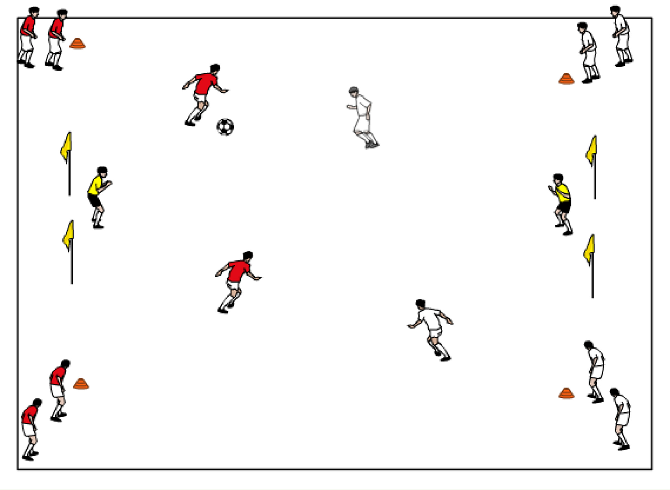
2v2 to goal — 2v2 to two goals (or flag/cone goals) on a 35-40 yards long by 50 yards wide field. Field players should be divided into two teams (each team at a goal standing in a line at each corner flag). First player in each line comes out to make it a 2v2 game. If a team scores, the two players stay on the field, turn and receive a new ball passed in from their team standing in lines on the post, and attempt to score another goal. If scored on, rotate out. If ball goes out of bounds, both teams rotate off.

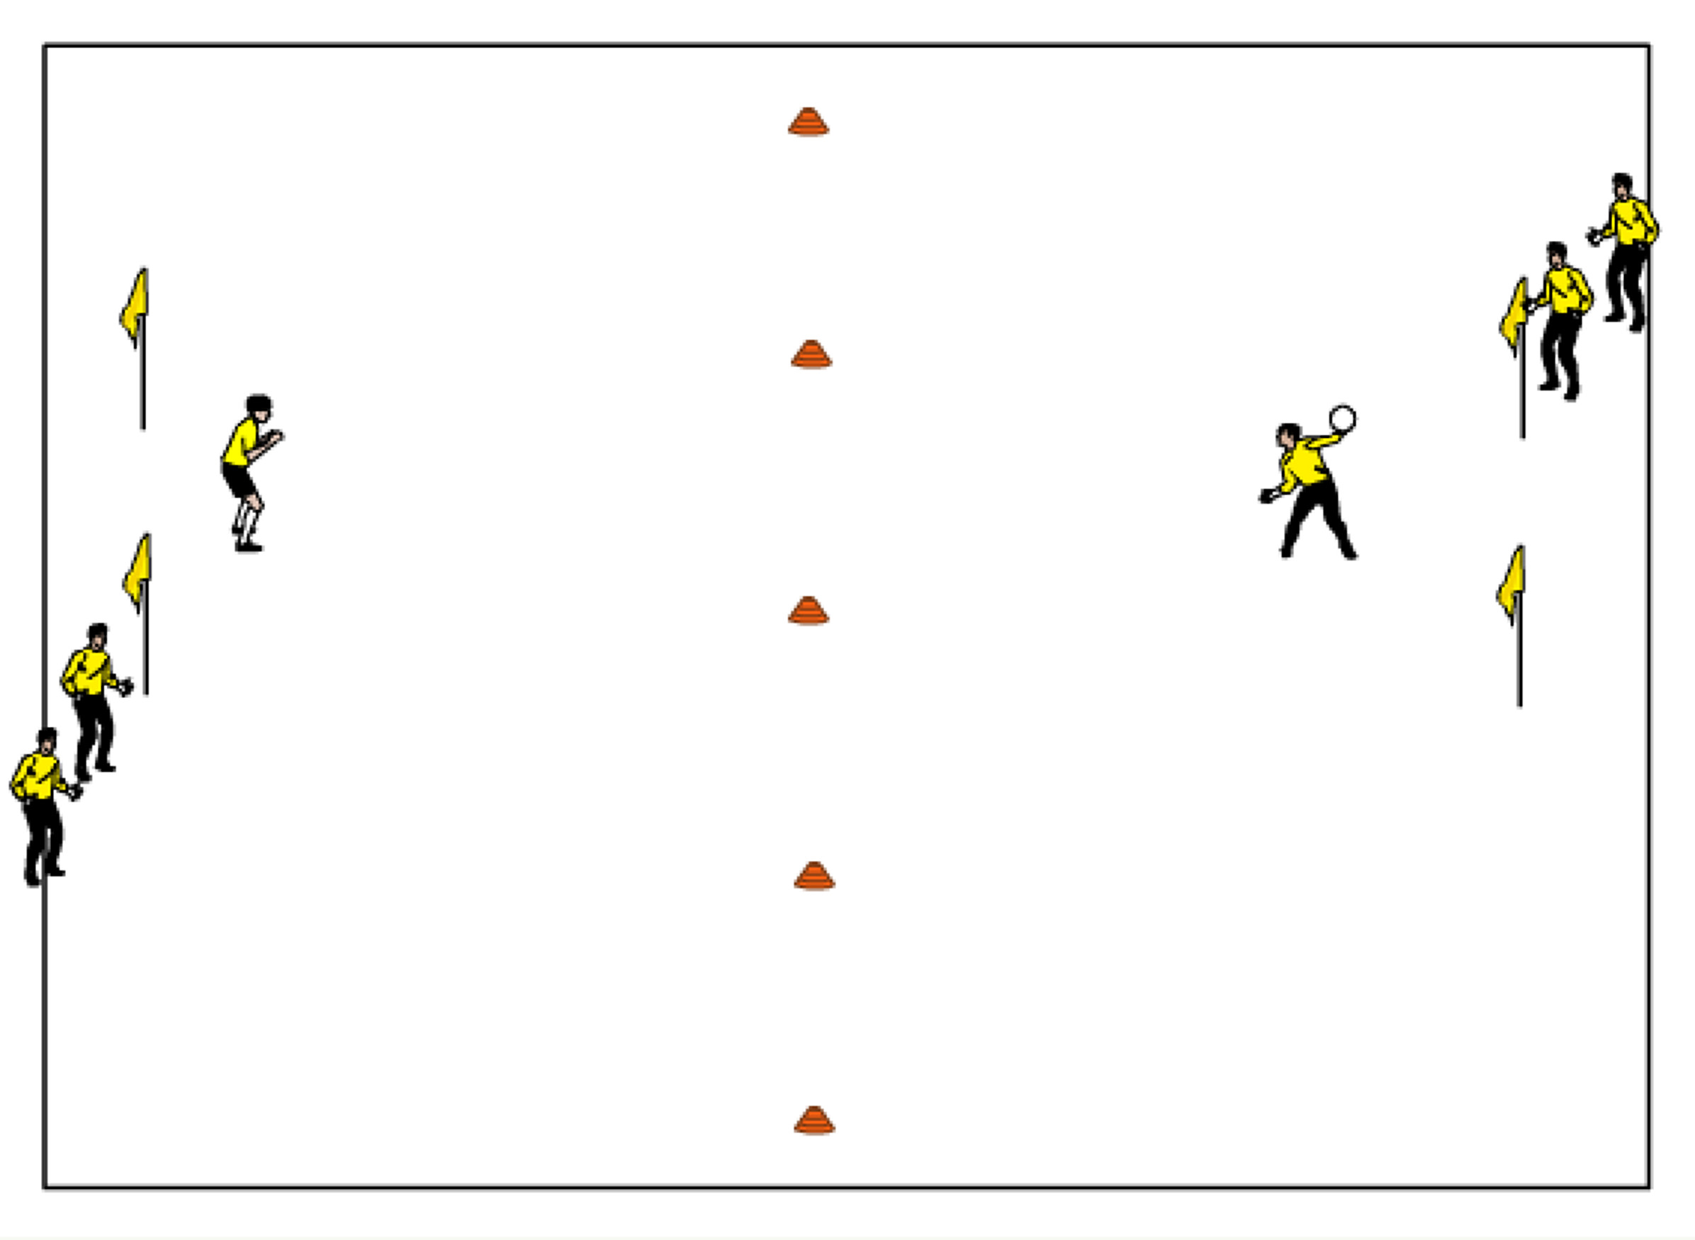
Mini GK Wars — In an area 30 yards long by 20 yards wide, use two cones or corner flag goals facing each other, one GK in each net, with a halfway line marked off. GK’s can round house throw, baseball throw or bowl to score on each other. Ball must bounce in other players half for the goal to count. If scored on, next GK rotate in (about 3 GK’s per goal on one of the posts.) If no goal is scored within a 1-2 minute time period, both GK’s rotate. Encourage proper technique when distributing and diving. (Maximum activity length: 20-25 minutes

GK Wars— In an area 25-35 yards long and 20-25 yards wide (adjust if necessary), with a goal at either end, and a half way line marked off by a line of cones. GK’s can shoot, half volley, bowl, baseball throw or round house throw the ball into the opponents net to try and score, not going over halfway line. If scored on, next GK rotate in (about 3 GK’s per goal on one of the posts.) If no goal is scored within a 1-2 minute time period, both GK’s rotate. (Maximum activity length: 30 minutes)

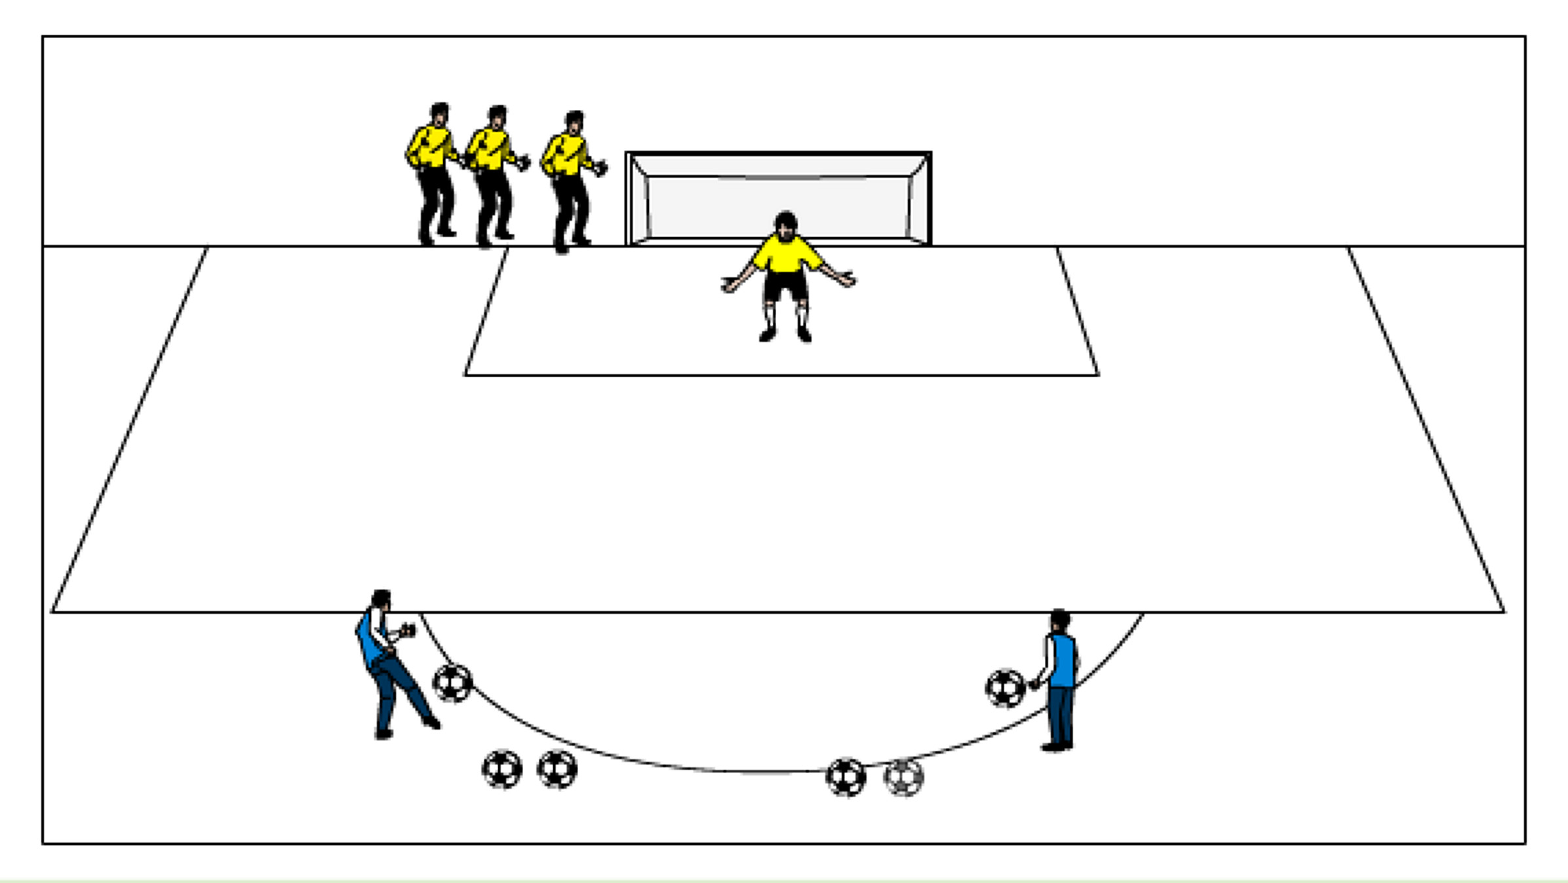
Shots on Goal—Have two servers (coaches), each centrally located at the top of the 18 yard box. Each GK should handle 4 shots total, alternating from each server then rotate out. The first few rounds the shots should be at the goalkeepers, warming them up and building their confidence, then begin to challenge them. Rotate quickly to keep the keepers active. Maximum 5 goalkeepers per goal. (Goalkeepers should handle about 20 shots or more each)

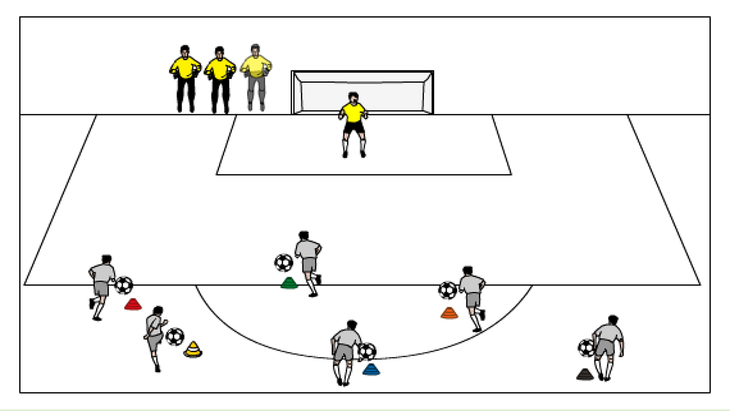
Color Shots – There are different colored cones or jerseys on a central arc about 16-20 yards outside of a goal, each with a server and several balls. One GK starts in net and as the coach calls out a color, the GK must adjust their positioning and be ready for the shot, based on what color the coach calls. Rotate after 5 shots. Each goalkeeper should rotate through at least 4 rounds of saves.

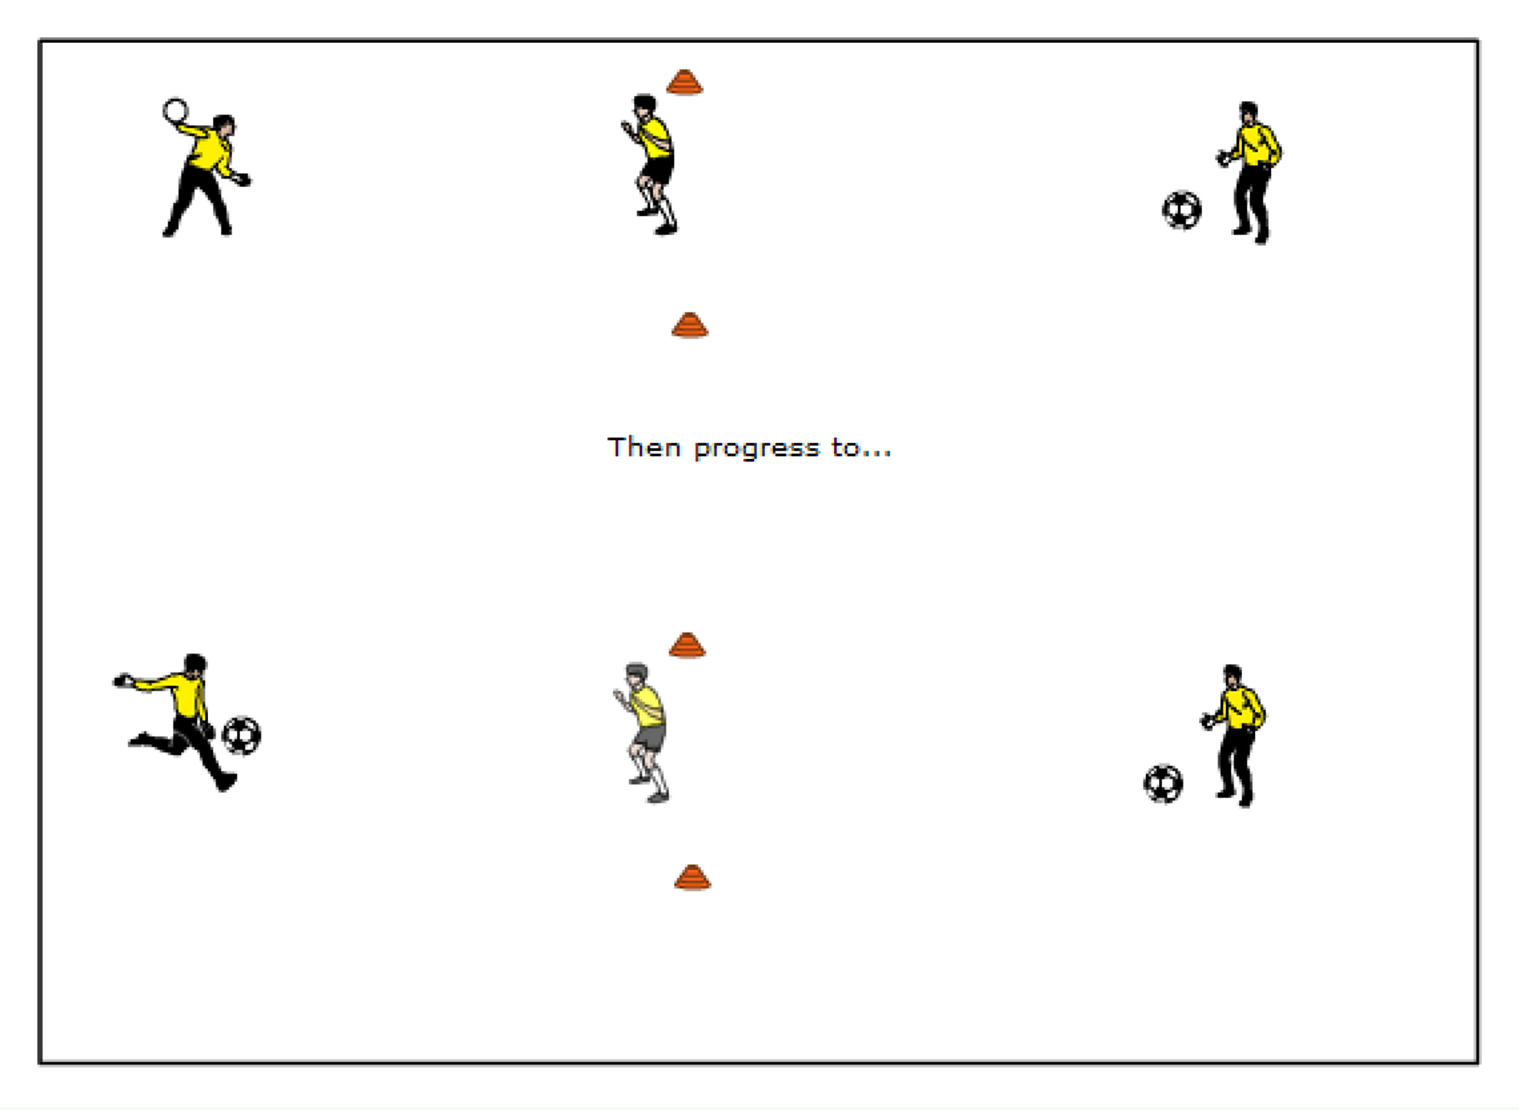
Two Saves –GK’s in groups of three with two cones 6 yards apart. One GK stands between the cones, the others are about 15 yards away on each side of the cone goal. GK faces one server who shoots the ball at the keeper to make the save. While this is happening, server 2 is moving their ball so after working GK makes 1st save they must turn to server two behind them and find the new positioning of the ball to make the save. Keeper immediately turns and finds the other ball and shooter who has moves again. Each keeper makes about 8 saves successfully then rotate. To start, the service can be a roundhouse throw, then progress to a foot service (shot) from the ground. Allow the Goalkeepers to have two rounds with service from a throw, then two from the ground.
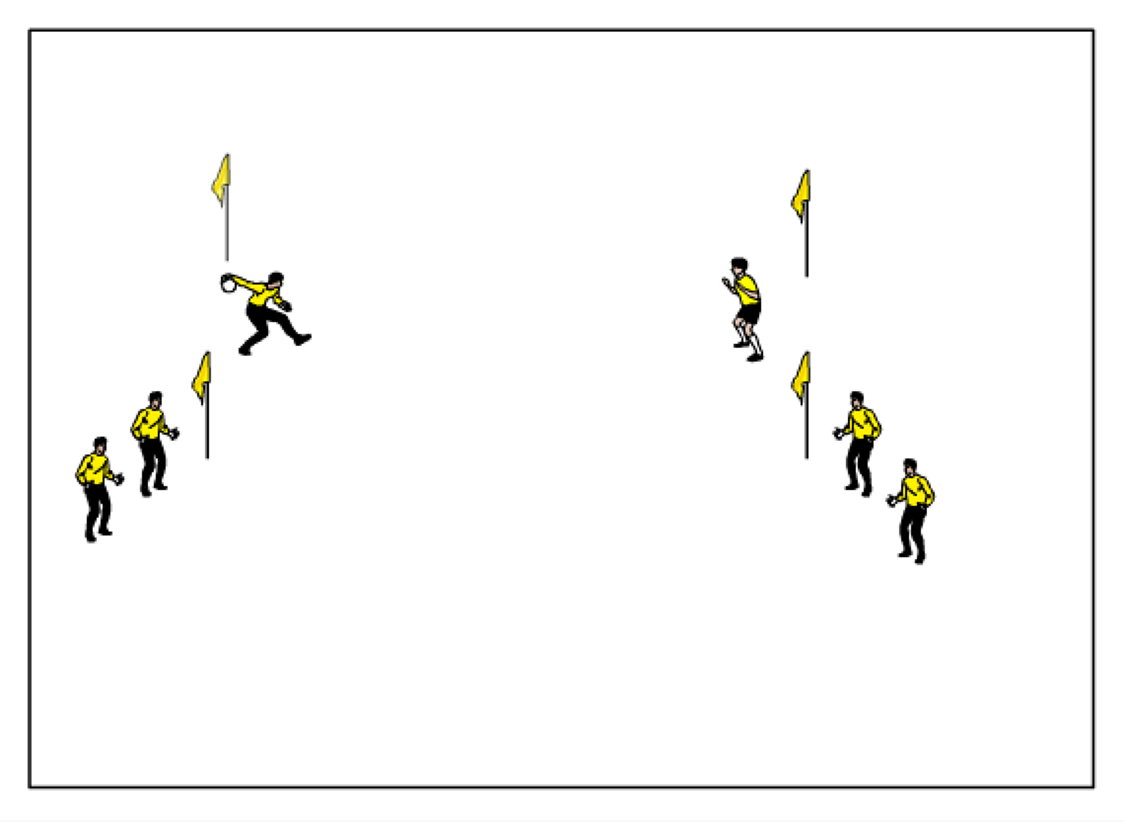
Partner Catching / Distribution –Two lines of players, each in between a cone goal, facing each other with one ball (maximum players per line is 3). GK A BOWLS (and then follows their service) to GK B who scoops it up and brings it in to their body. GK B then BOWLS to the GK behind GK A to continue the cycle. After several rounds, balls should be BASEBALL THROW, then ROUNDHOUSE throw at head level, then to high balls. Version 2: Within each round, have the server put slight pressure on the working GK. Version 3: Now the keepers have to shuffle through 5 cones in a vertical row in front of their net, and set for the service. Each goalkeeper should make about 8-10 saves per round of distribution. (bowl, baseball throw, roundhouse)

U12 GK ACTIVITIES
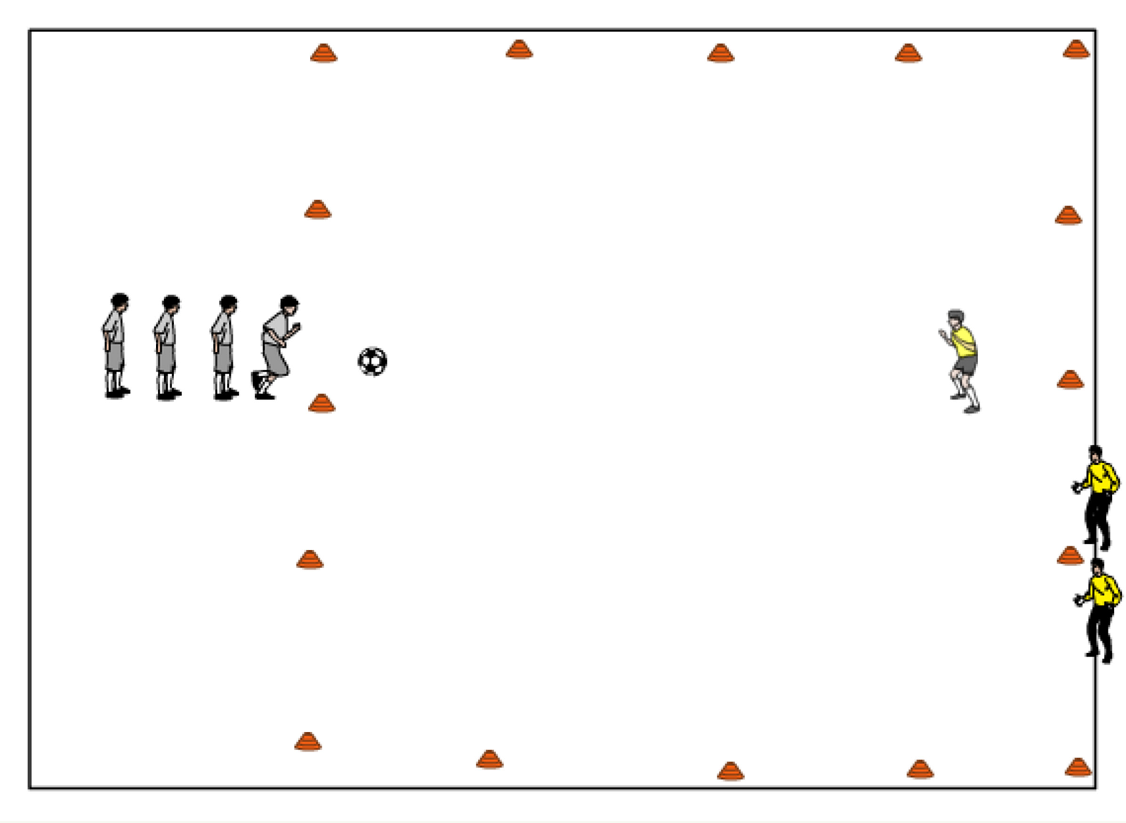
1v1 Grid Challenge —An attacking line with field players sets up centrally at one end of the grid (15widex20long) and the GK line at the opposite end. The GK rolls ball to the attacker who must dribble over the opposite endline (the goal the GK is protecting) with possession for a point. Keep track of goals scored for a competition. Maximum 4 players in each the attacking line and GK line, rotate after each shot. GK should be looking to cut down the angle and force the attacker to one side. (Maximum length of activity: 20 minutes)

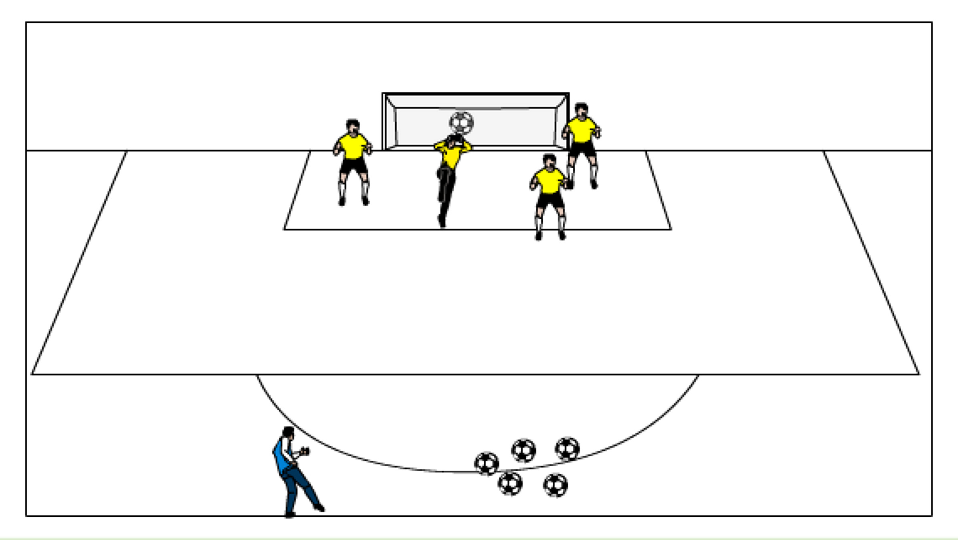
Number high balls — All GK’s in the 6 yd box with a number (Maximum 6 GK’s), coach is outside the 18 yard box centrally with balls. Coach yells out a number and serves a high ball towards the top of the 6. The GK must work their way through traffic and get the ball at the highest point, using the proper leg for protection calling out “keeper”. Version 2: Coach can move to the outsides and serve from there so the GK’s now have to deal with balls served in from the flank. Coach can also call out two numbers so the GK’s have to compete for it. (Maximum length of activity 20 minutes)
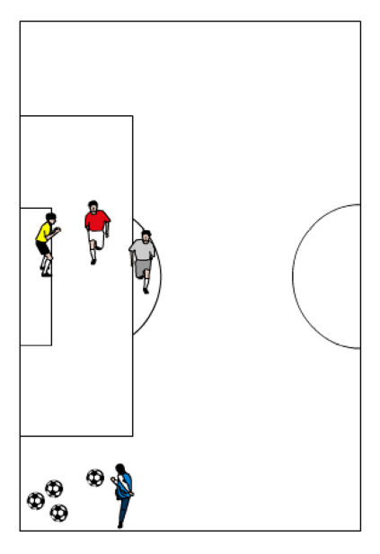
Crosses, GK+1v1 — One keeper in goal plus one defender and one attacker (gray). Coach or server is on the flank beyond the side of the PK area serving crosses. After about 5-8 repetitions, players switch rolls. Then rotate to the other side. Each keeper should get three; 5-8 repetition rounds per side. GK must be loud in yelling “keeper” or “away”. Encourage the GK’s to test their range. Also, have them recognize on a driven ball, their range will not be as far out as if the ball is lofted into the box. Keep score for a competition for how many balls dropped or scored upon. Field players are passive at first and then begin to increase pressure.

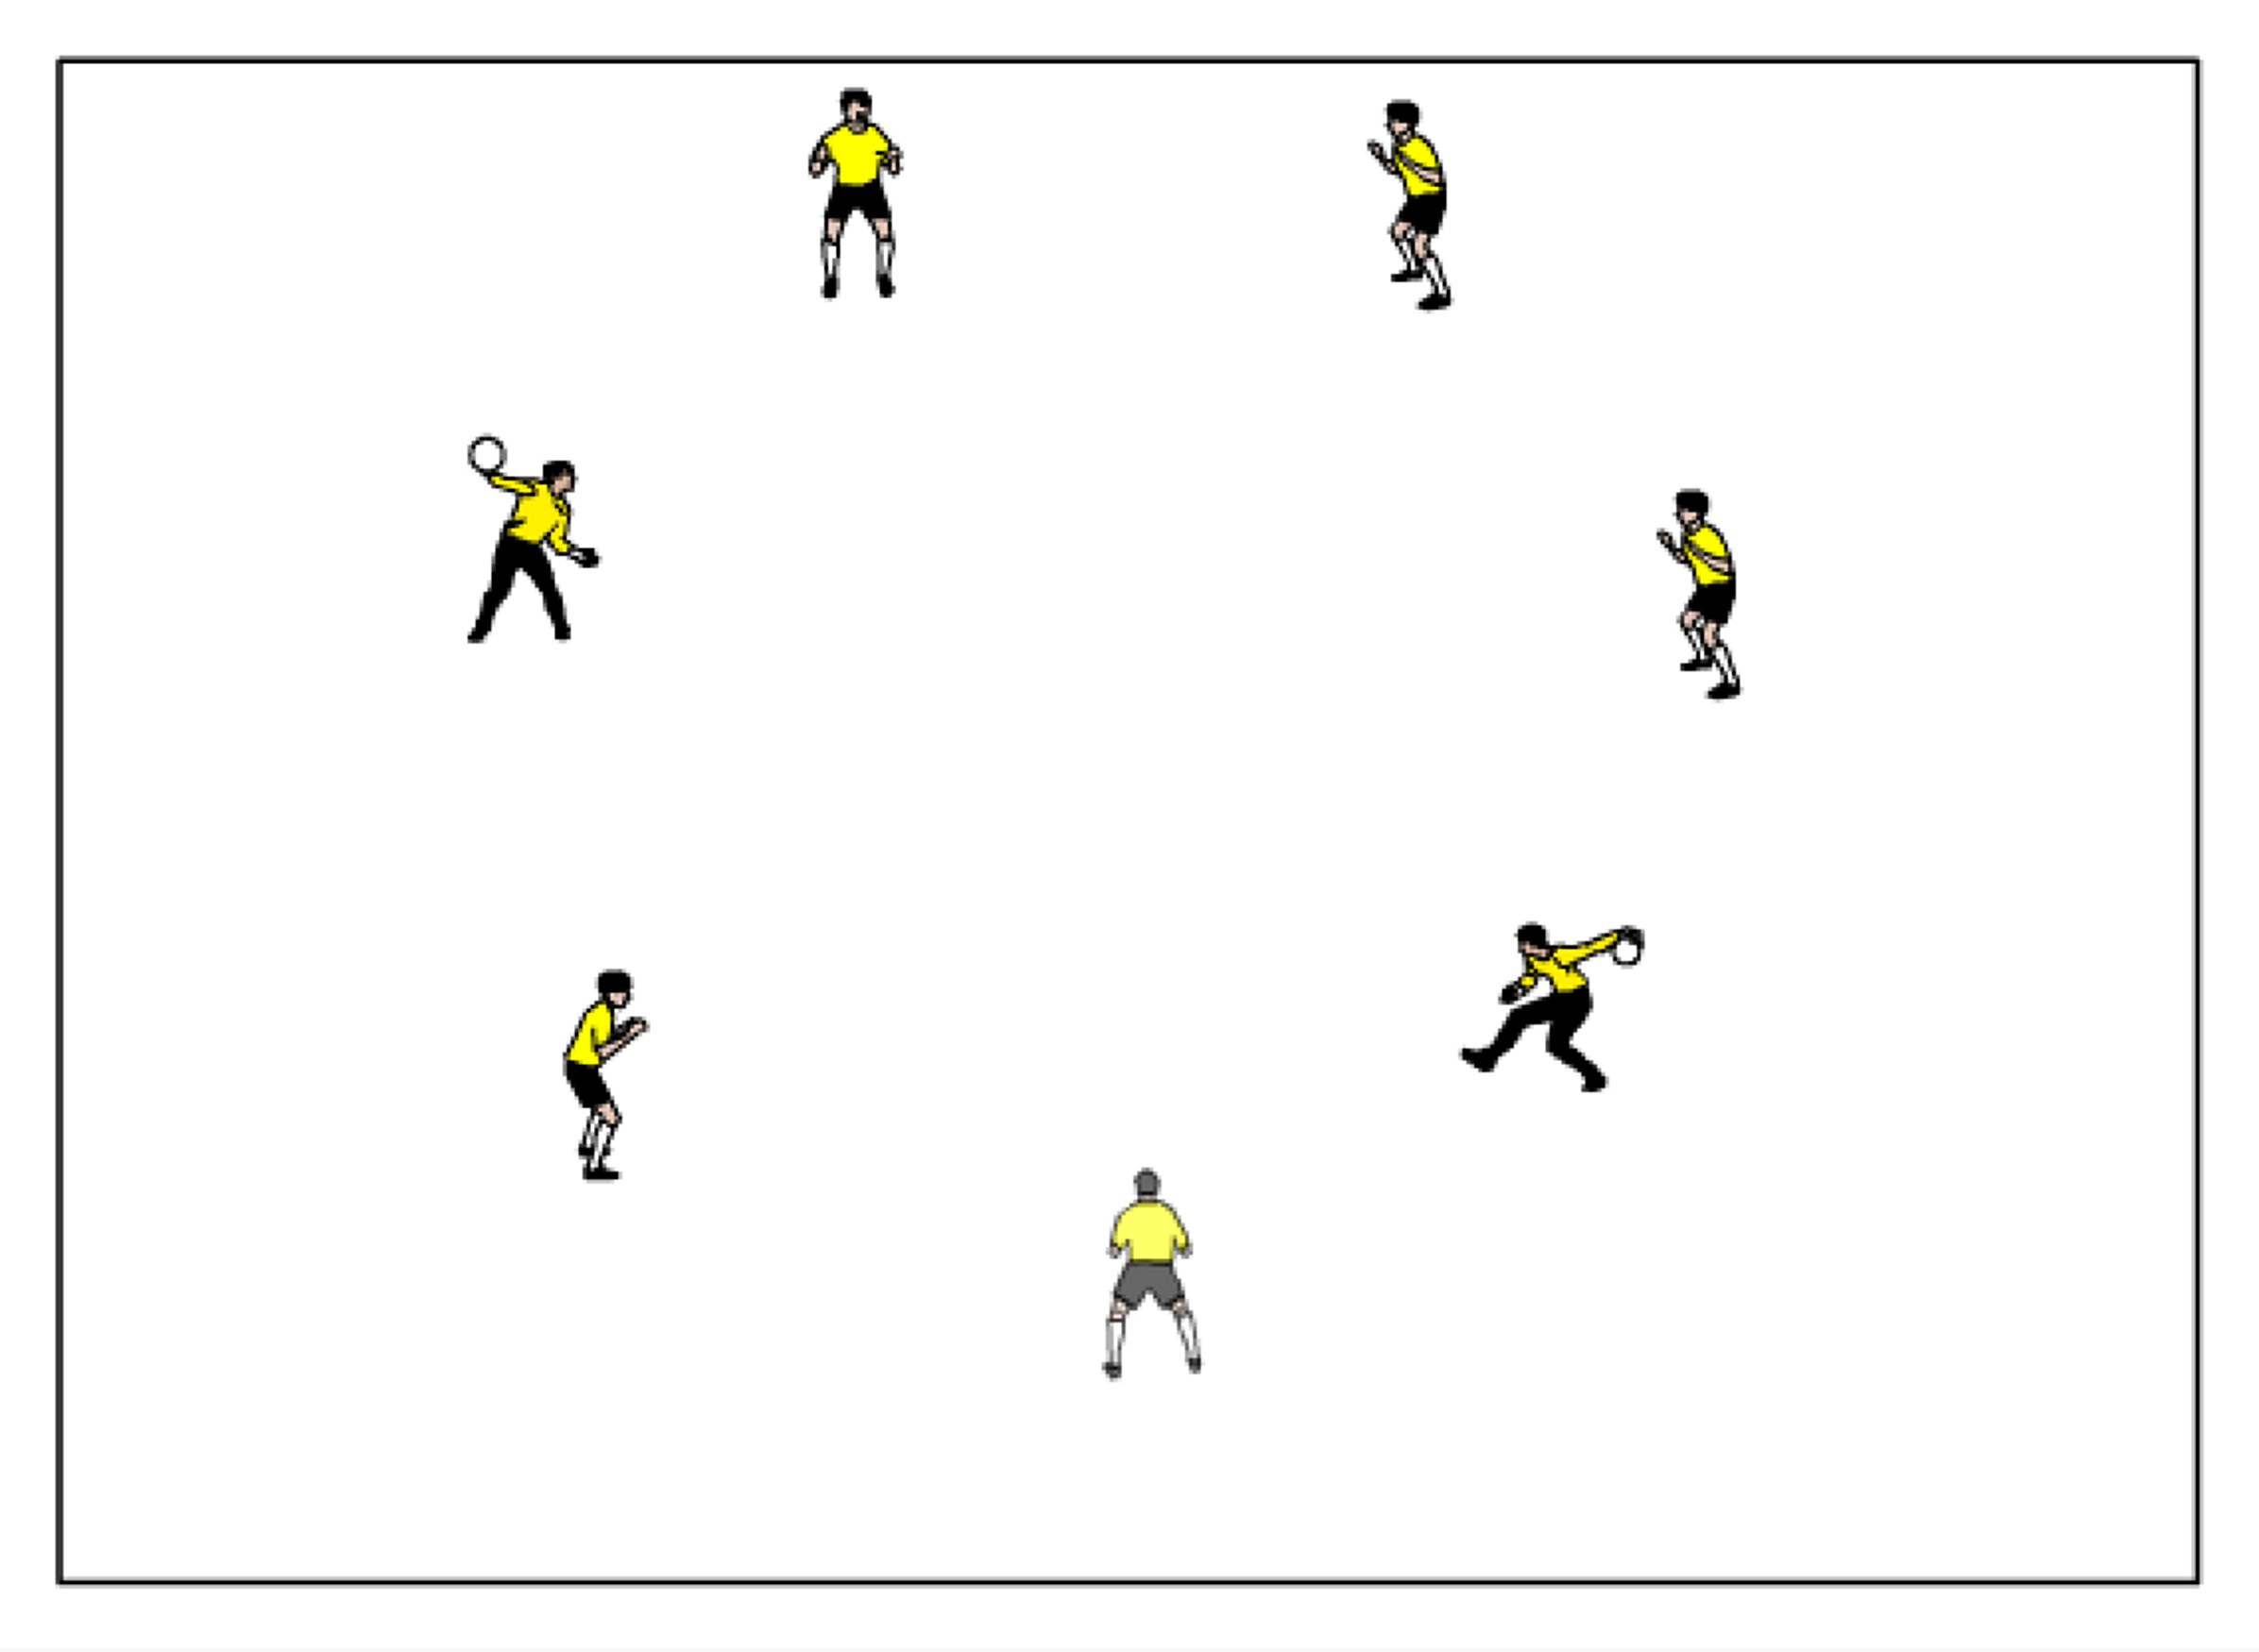
Two ball Circle –GK’s stand in a 10-15 yard diameter circle with one ball involved that can be passed at the shoulder height level to anyone except the player next to you. A second ball can be added once a rhythm is obtained. Then progress onto to skip balls, and rolling balls with pace. Instill into the players proper footwork to get their body behind each ball. There should be a high amount of communication between the keepers. Instill proper, accurate distribution. (Maximum activity length 15-20 minutes)

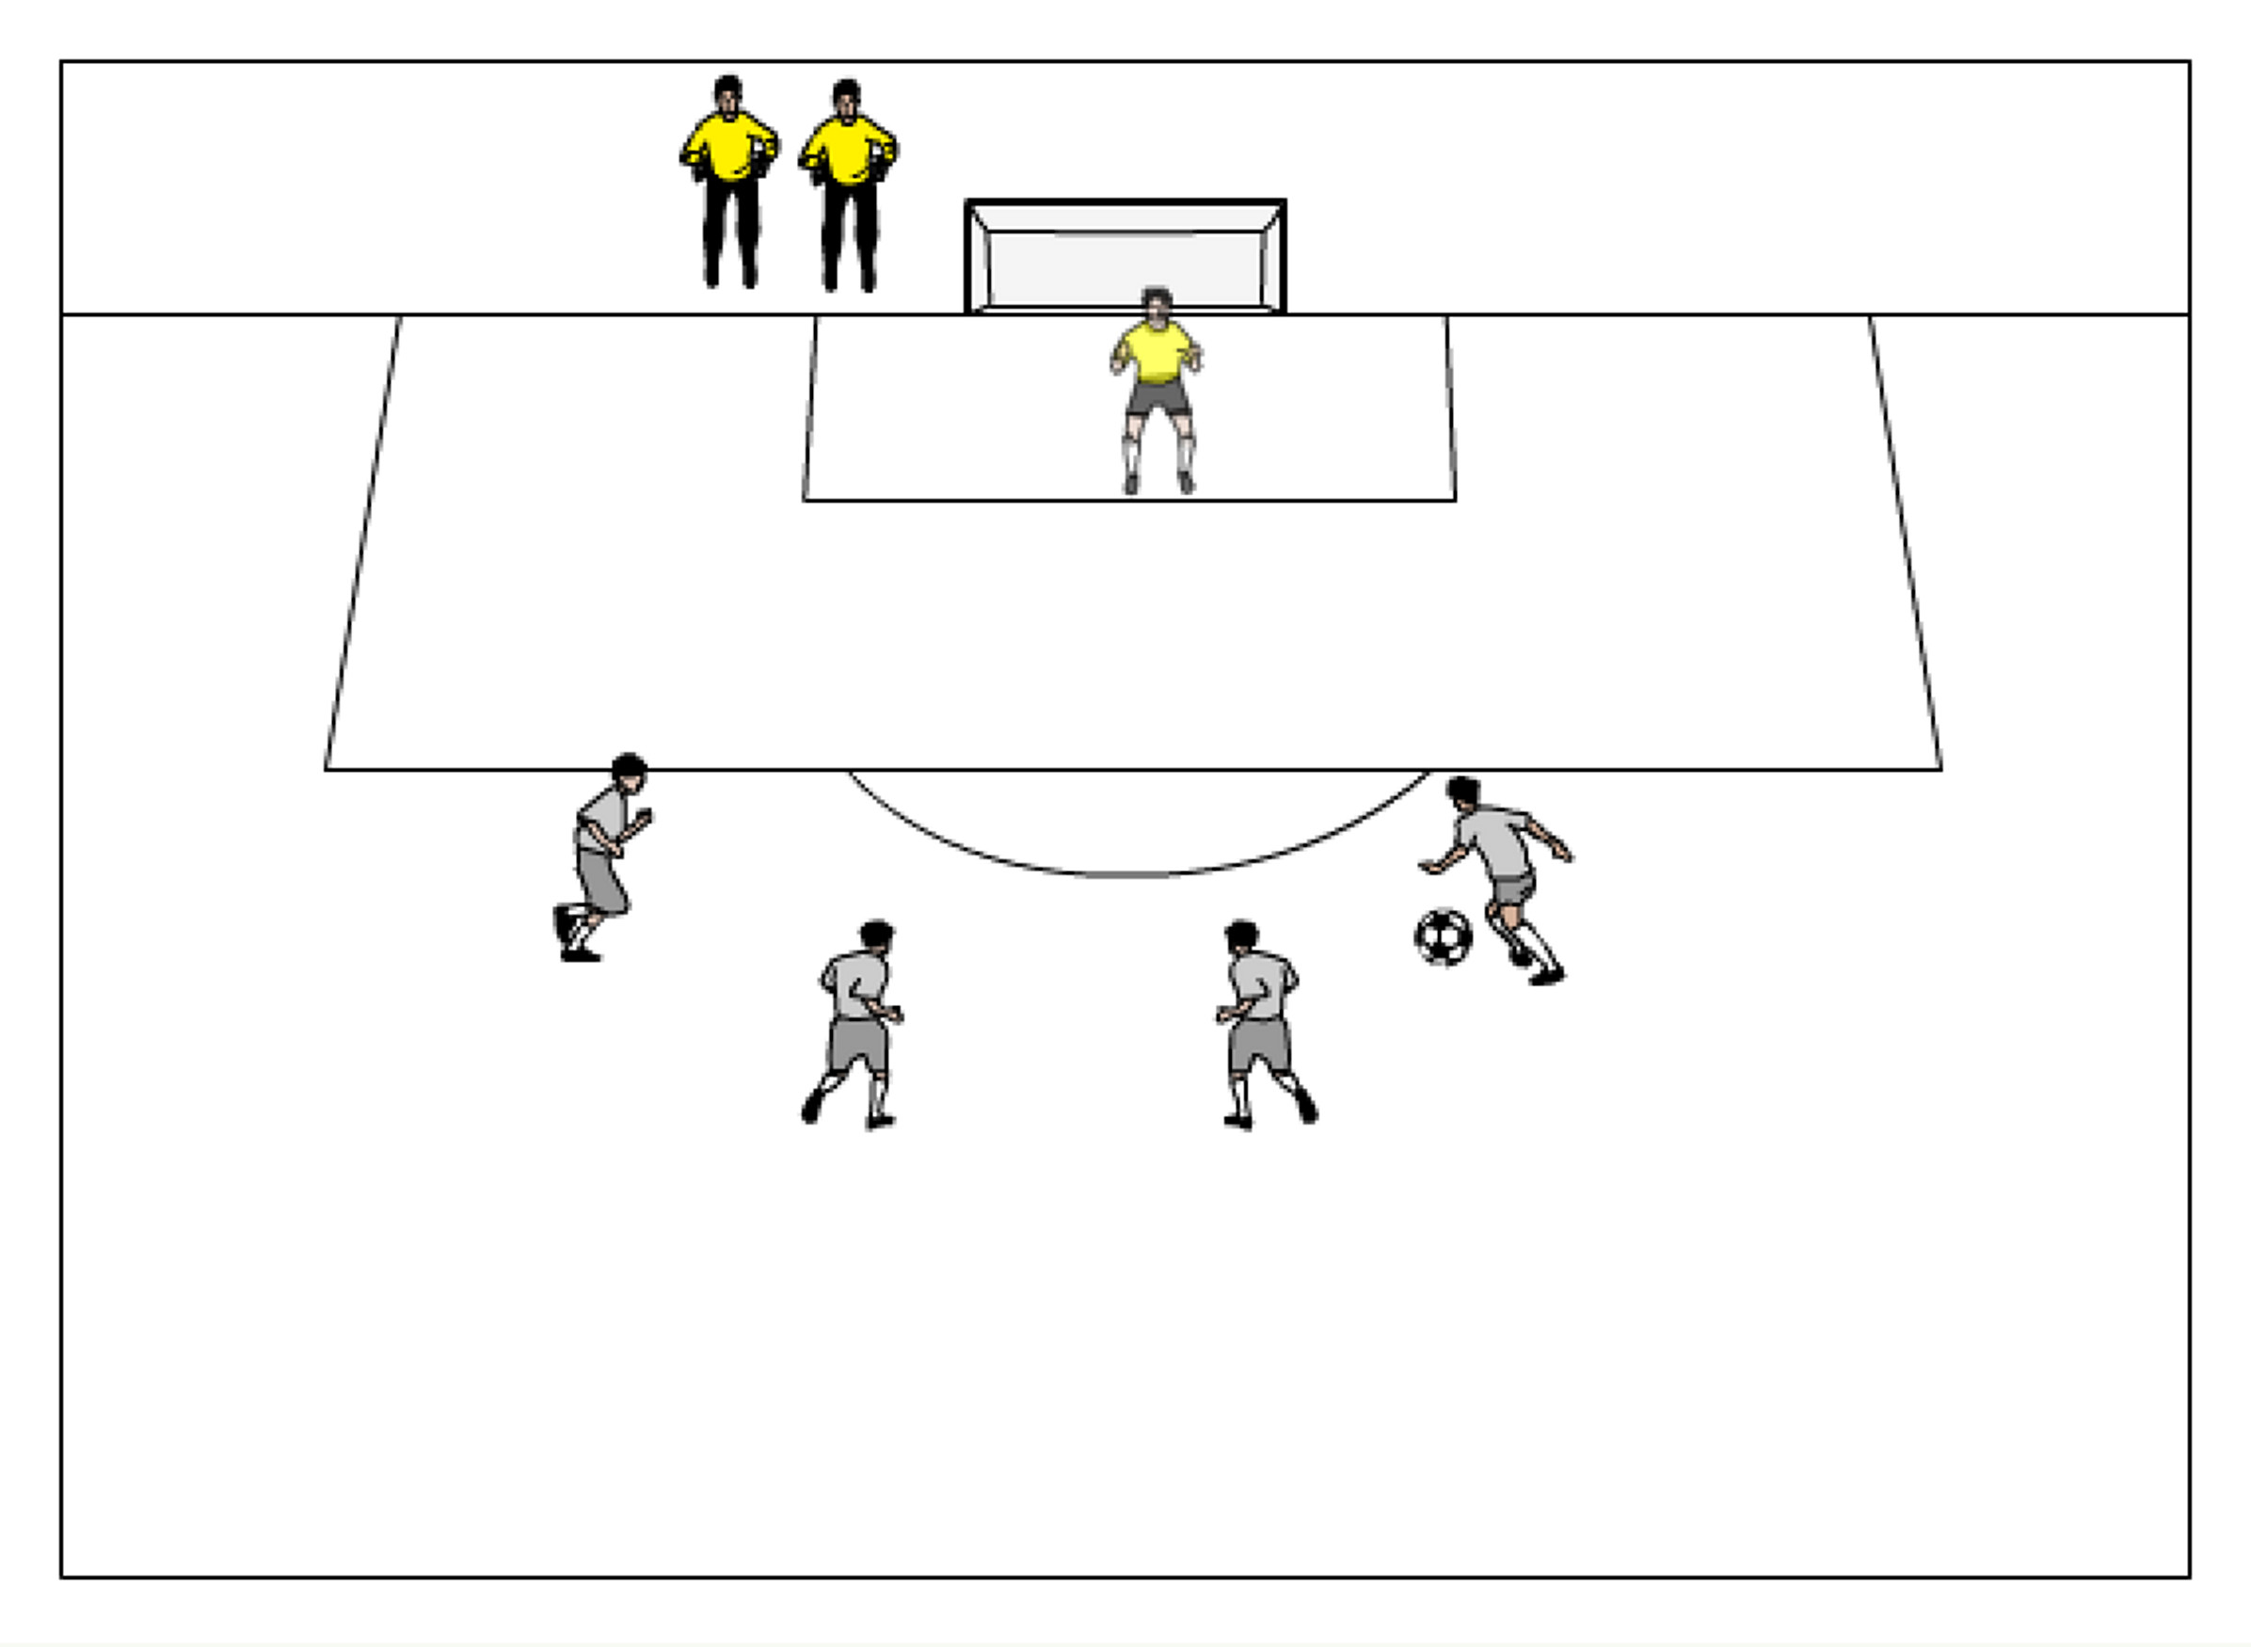
Moving ball - three or four players are on the arc around the 18 yard box (centrally) passing one ball while the working GK is using their footwork to constantly reposition themselves to be ready for a shot. At any point, a server can take a shot, especially if they think the keeper is out of position. Rotate after 5 shots. Each goalkeeper should get at least four rounds in the net. Servers should look to move the ball quickly to make it challenging for the goalkeeper.

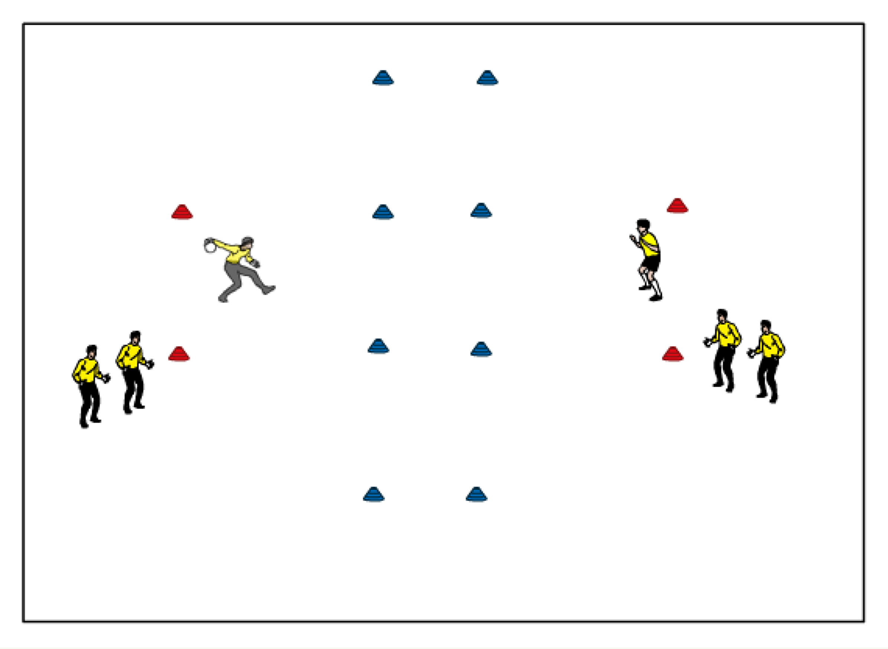
Small Goal Saves -- Two lines of players, each in between a cone goal, facing each other with one ball and extras on the sides. (maximum players per line is 3) Goals should be about 35-40 yards apart with a 10 yard buffer zone in the middle. Keepers are now trying to score on each other by either throwing or bowling it but the ball must bounce on the opponents half before a goal is scored. GK gets a point for a goal. Once a GK gets scored on, next person in line hops in. (Maximum activity length: 25 min)

2v2 to goal — 2v2 to goal on a 35-40 yards long by 50 yards wide field. Field players should be divided into two teams (each team at a goal standing in a line at each post). First player in each line comes out to make it a 2v2 game. If a team scores, the two players stay on the field, turn and receive a new ball from their team standing in lines on the post, and attempt to score another goal. If scored on, rotate out. If ball goes out of bounds, both teams rotate off.

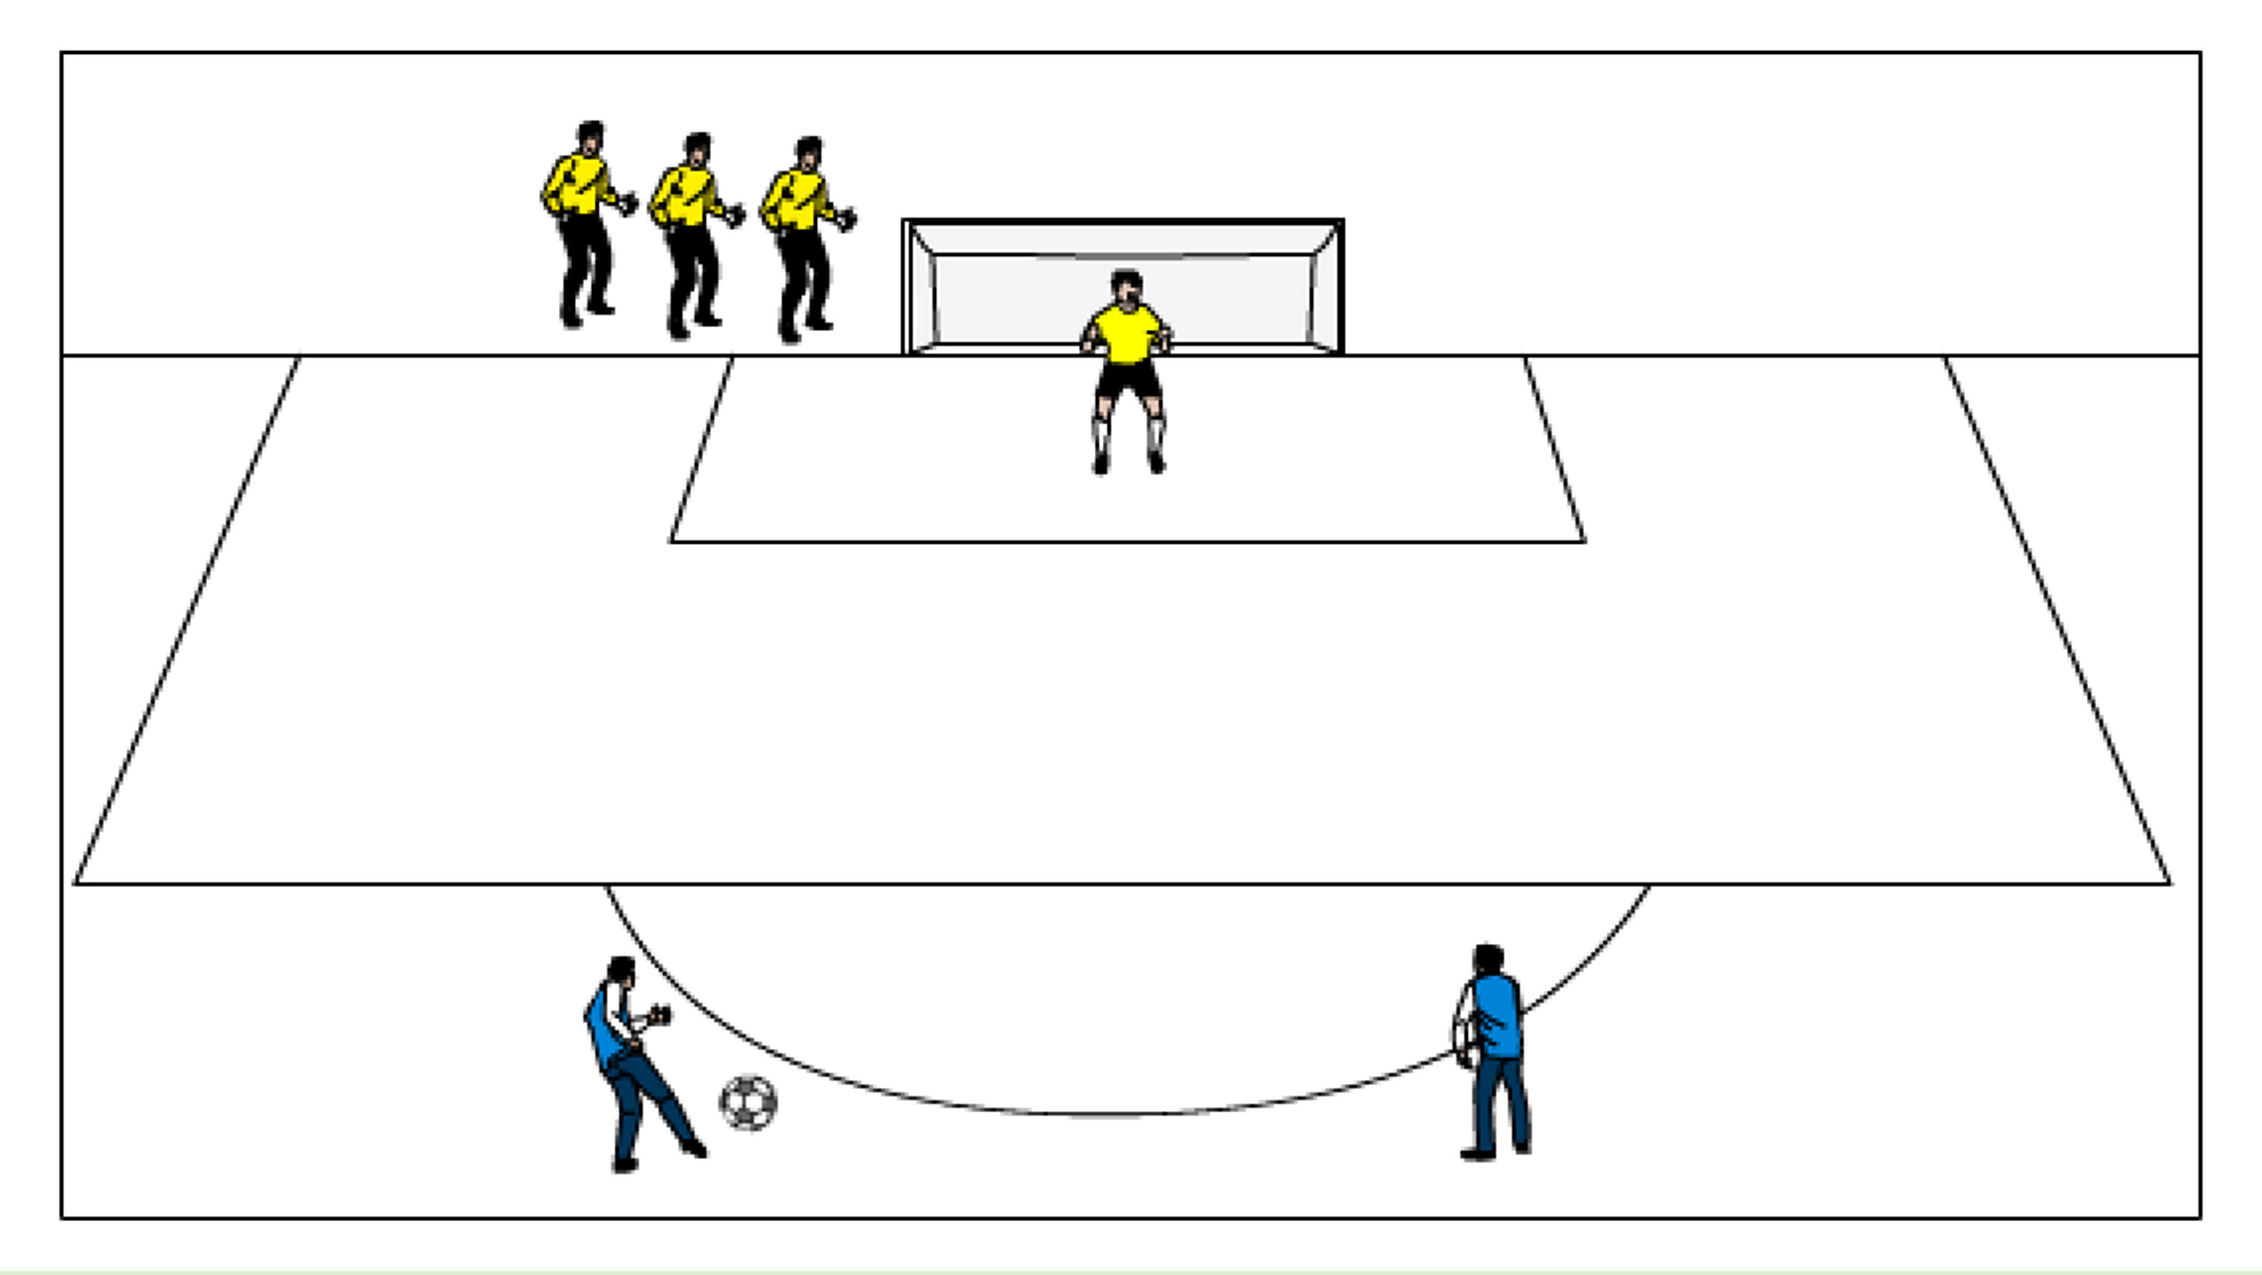
25 yard shooting — 2 servers, about 25 yards out pass back and forth (quick passes) then at any point a server can take a touch towards goal for a shot or breakaway. GK has to read the pace on the ball and the player and make a decision to come off their line or be ready for a shot. Rotate the GK’s after about 5 repetitions. Each goalkeeper should handle at least 20 shots.

Color Shots – There are different colored cones or jerseys on a central arc about 16-20 yards outside of a goal, each with a server and several balls. One GK starts in net and as the coach calls out a color, the GK must adjust their positioning and be ready for the shot, based on what color the coach calls. Rotate after 5 shots. Each goalkeeper should rotate through at least 4 rounds of saves.

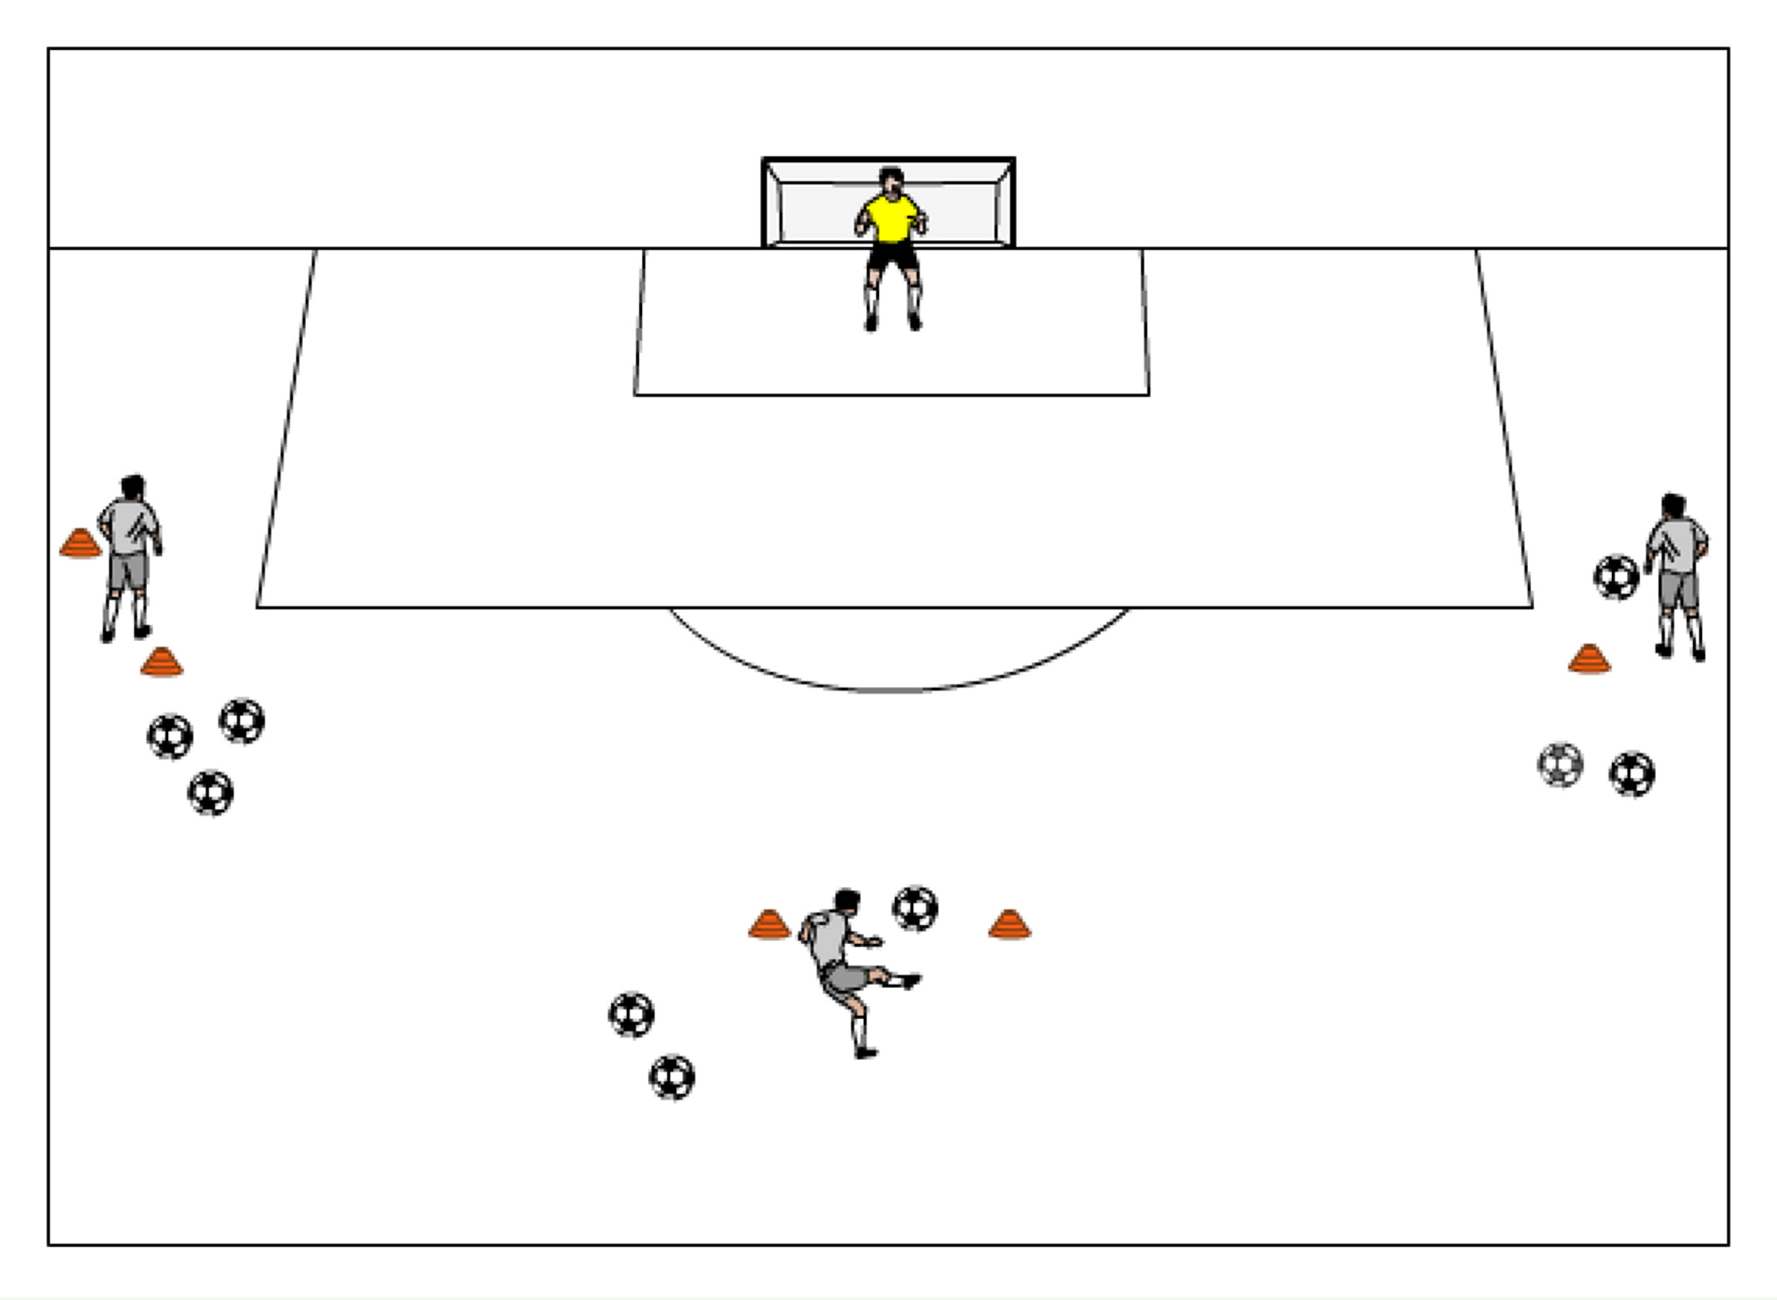
U14 GK ACTIVITIES

Three Saves- Three servers on the top of the 18 yard box, one centrally, one on each corner of the 18. Each server has a number (1, 2 or 3) and yells out their number when they are going to shoot next. GK’s need to make sure to cut down the angle and set their feet before each shot and are not still moving when the ball is struck. Take about 5-8 repetitions and then rotate the goalkeepers. Each goalkeepers should have at least 4 rounds.

Extension Diving for height –Work in pairs, one server, one GK. The keeper kneels with one knee on the ground, one knee up (this is the side they are diving to). Server holds ball in palm of one hand about head height a few yards away from the keeper and a bit in front. Keeper pushed hard with the near leg and drives to the ball, catches off server’s hands and lands properly. Working goalkeeper performs about 3-5 dives each side, then rotate. Goalkeepers should go through about 3 rounds total.

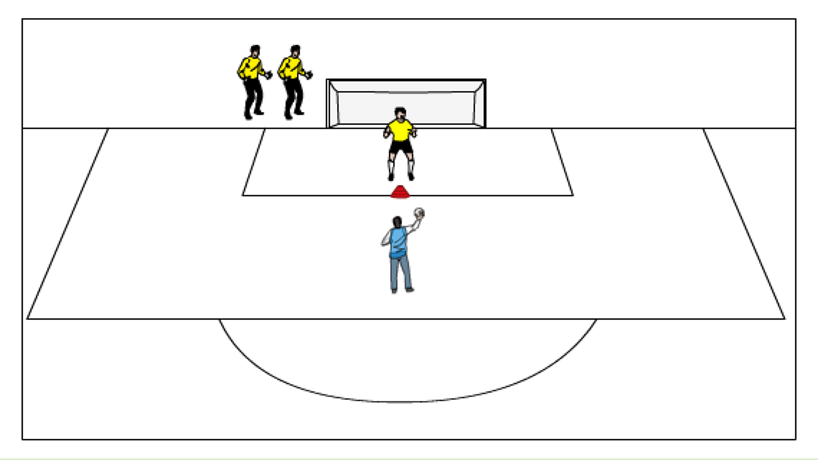
Parrying over the bar– Have goalkeepers come off of one post, touch a cone about 6 yards in front of the center of the goal, and a ball is served from the about the 16 yard line over their head to one side. Keepers now must do the proper footwork (drop step, then either a shuffle or crossover step), they should use their opposite hand to deflect the ball upwards over the crossbar. At first, indicate the direction before the throw. As the keepers get more comfortable, increase the difficult of the throws by making them more direct and at a faster pace. Keepers should go one at a time, maximum three keepers per goal. GK’s should get at least 15 repetitions per side.
1v1 Grid Challenge —An attacking line with field players sets up centrally at one end of the grid (15widex20long) and the GK line at the opposite end. The GK rolls ball to the attacker who must dribble over the opposite endline (the goal the GK is protecting) with possession for a point. Keep track of goals scored for a competition. Maximum 4 players in each the attacking line and GK line. GK should be looking to cut down the angle and force the attacker to one side. (Maximum length of activity: 20 minutes)

25 yard shooting — 2 servers, about 25 yards out pass back and forth (quick passes) then at any point a server can take a touch towards goal for a shot or breakaway. GK has to read the pace on the ball and the player and make a decision to come off their line or be ready for a shot. Rotate the GK’s after about 5 repetitions. Each goalkeeper should handle at least 20 shots.

Handball —Split the GK’s into two teams. Keep possession by passing to teammates with round house throw, taking a maximum of three steps when holding the ball. Keepers must catch the ball in the air past the end line in order to score. If ball hits the ground, it is the opposite team’s ball. Can defend opponents within an arms length away of them. (Maximum activity length: 20 minutes)

Color Shots – There are different colored cones or jerseys on a central arc about 16-20 yards outside of a goal, each with a server and several balls. One GK starts in net and as the coach calls out a color, the GK must adjust their positioning and be ready for the shot, based on what color the coach calls. Rotate after 5 shots. Each goalkeeper should rotate through at least 4 rounds of saves.
2v2 to goal — 2v2 to goal on a 35-40 yards long by 50 yards wide field. Field players should be divided into two teams (each team at a goal standing in a line at each post). First player in each line comes out to make it a 2v2 game. If a team scores, the two players stay on the field, turn and receive a new ball from their team standing in lines on the post, and attempt to score another goal. If scored on, rotate out. If ball goes out of bounds, both teams rotate off.

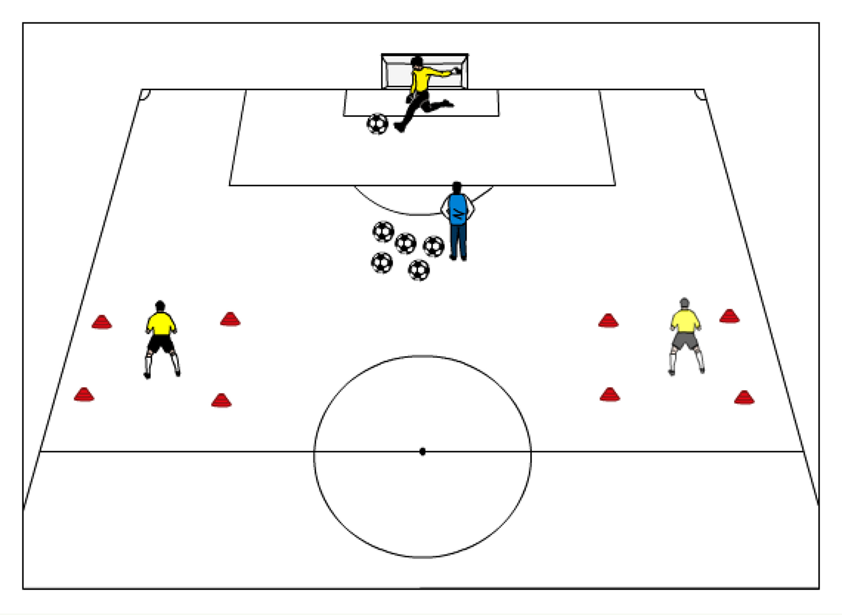
Pass back— GK in net, server is centrally about 25 yards out with all of the balls. Targets at half field (or closer) near the touch line in a 10 yard box. Server passes a ball back to the working GK who takes two touches and connects to one of the grids. Version 2: One touch the ball from the server and connect to targets. Version 3: Have a defender put pressure on working GK, starting their run from the 18 yard line so the GK has to make the right decision to play to the left or right, one touch or two touch. The goalkeepers should take about 15-20 repetitions per round. (two touch, one touch, with defender)

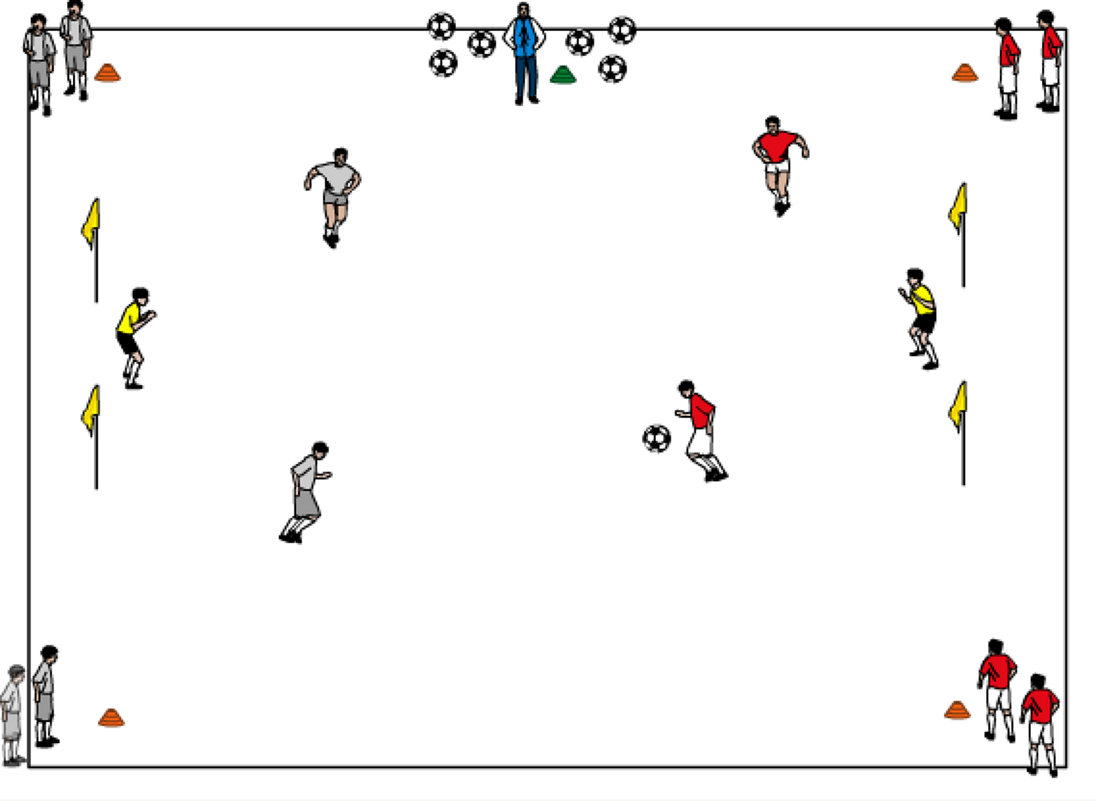
- U16 and above GK ACTIVITIES

Four Corner Shooting—On a field 25 yards long by 20 yards long, position two goals at each end. Split players into two teams (each team at a goal standing in a line at each corner flag) The coach is positioned at the midfield line, outside the field, with all the soccer balls. When the coach kicks a ball into the field, the first person in each of the four corner lines enters the field to play a 2v2 game plus goalkeepers. Play continues until the ball goes out of bounds or a goal is scored. When this happens, all players rotate out and go back to their original lines except the goalkeepers who will rotate about every 5-10 minutes. The next four players are up, and the coach will serve the next ball into play.
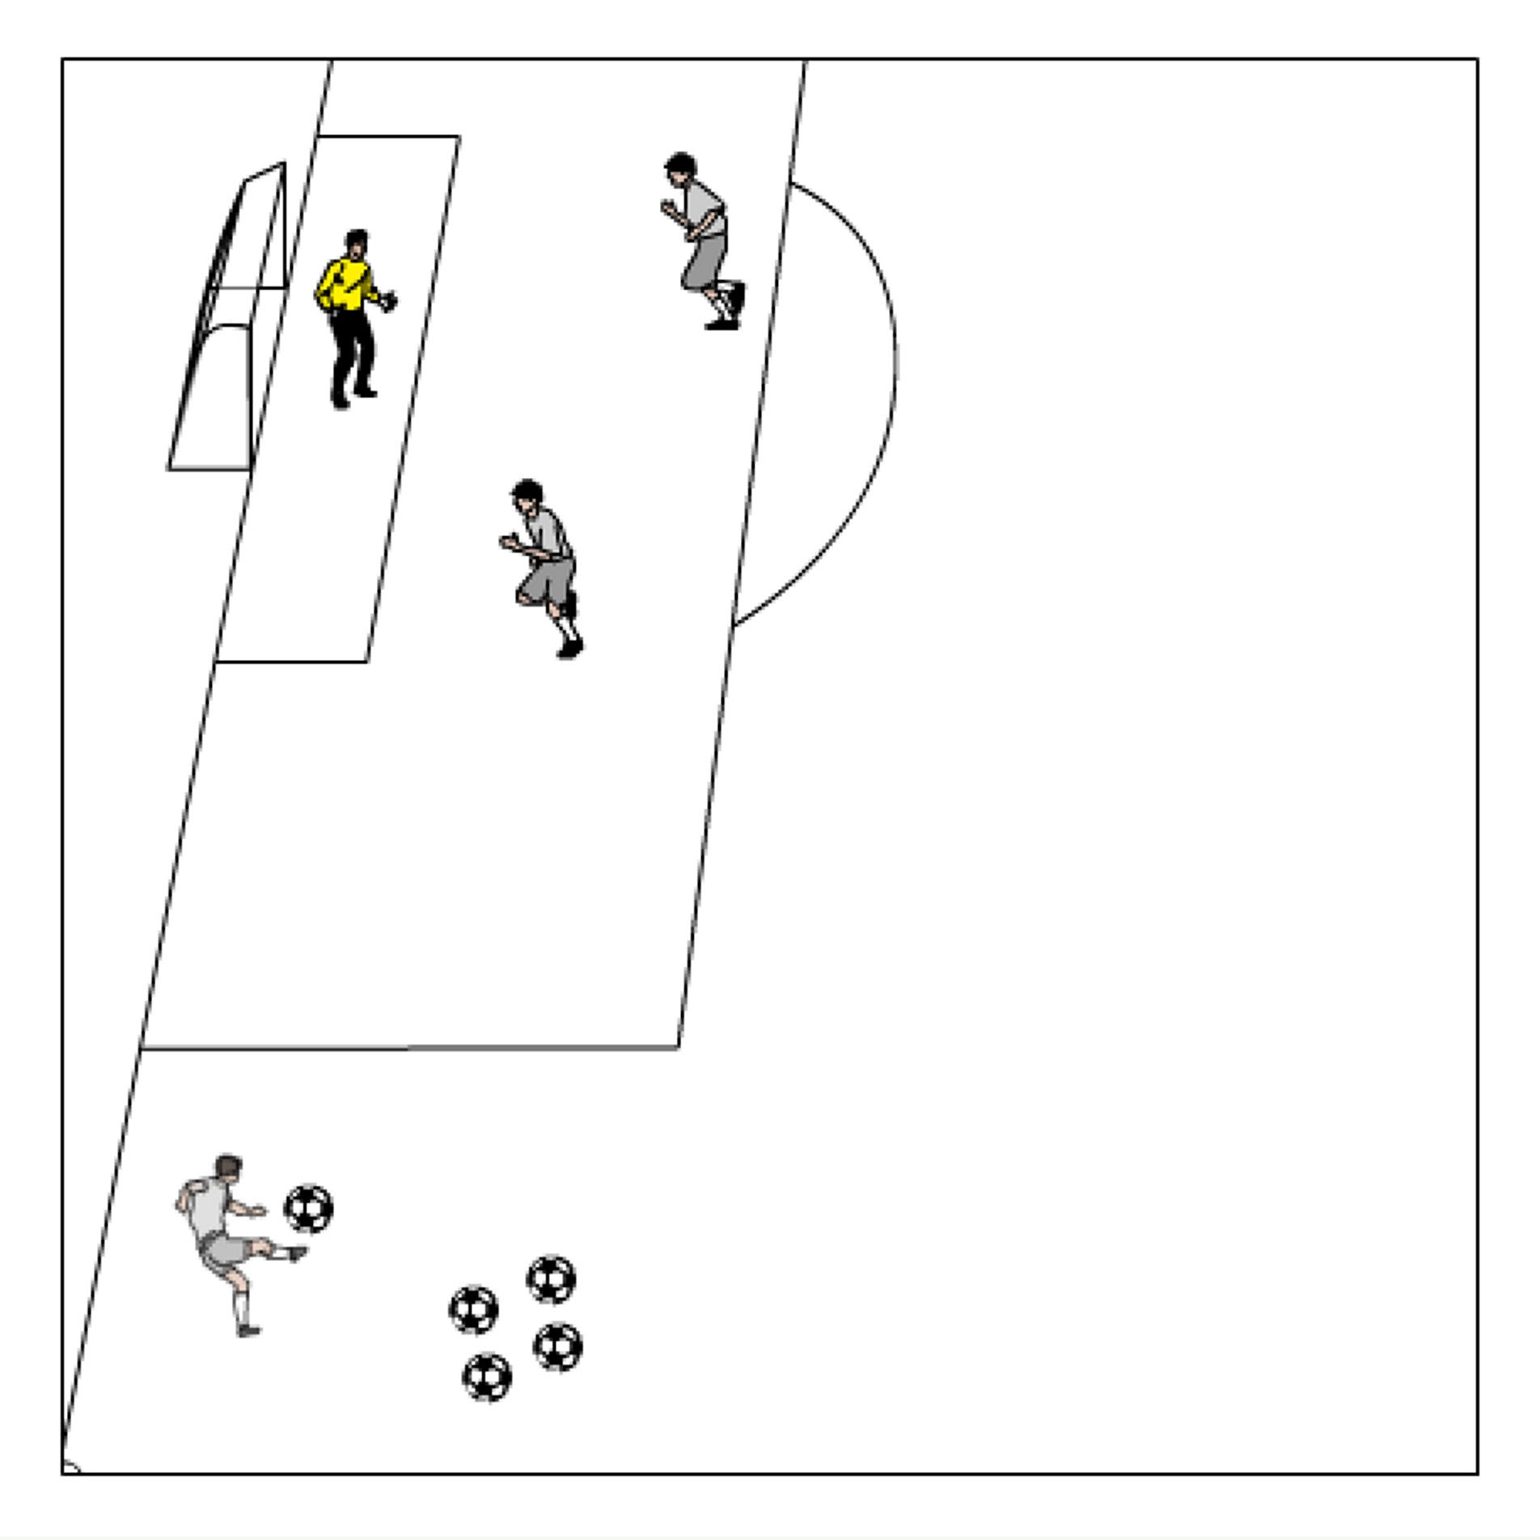
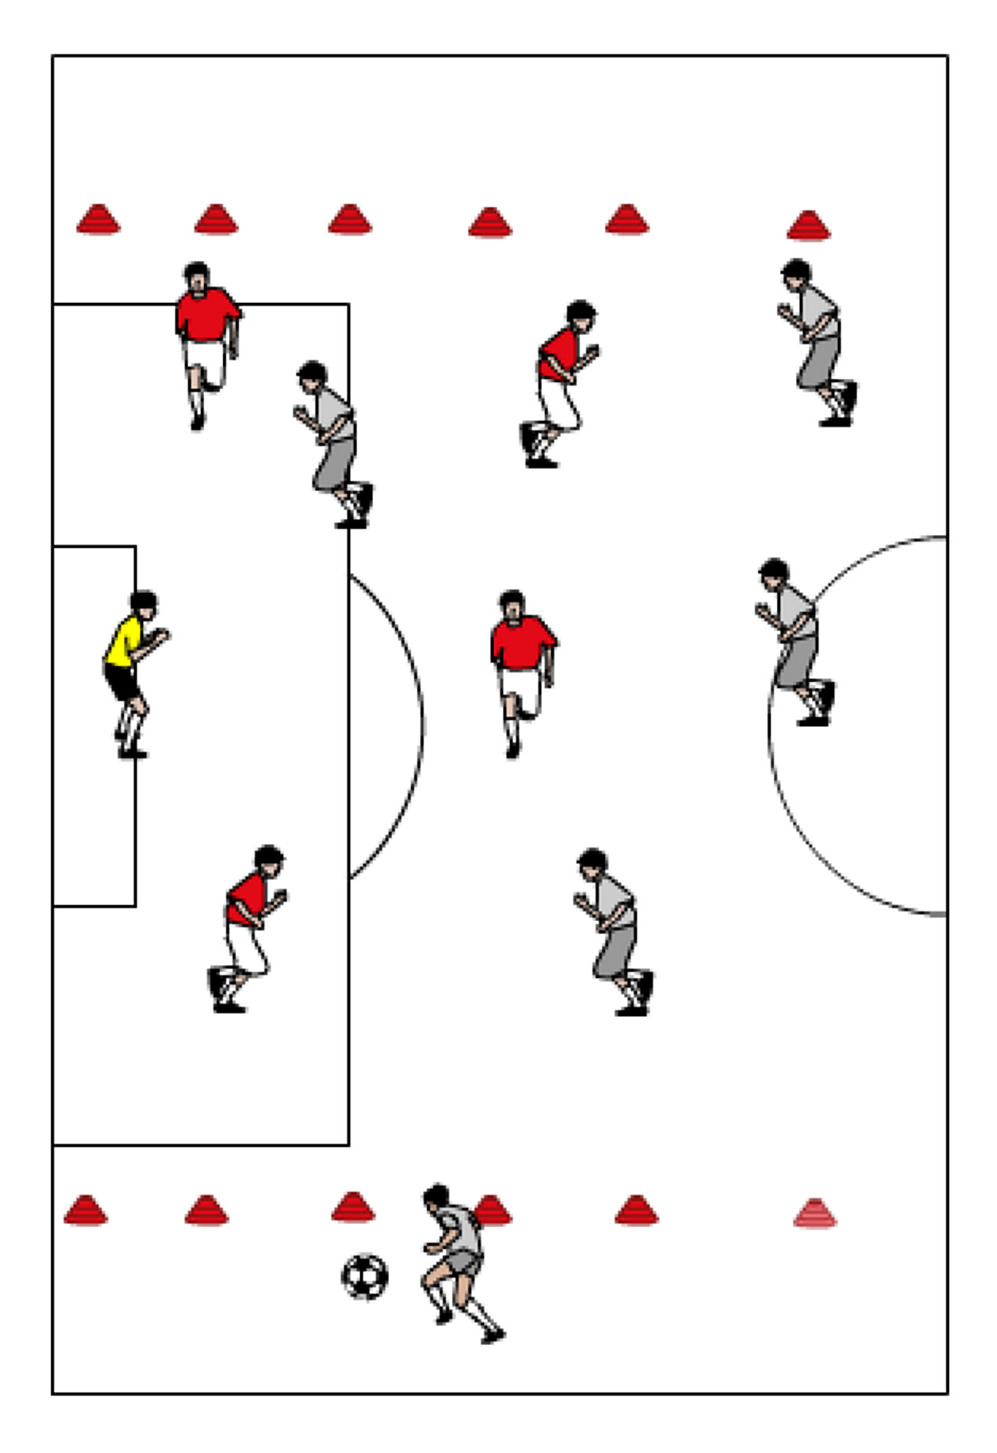
Handling Crosses ---Serve balls (either kicked or thrown) to a keeper from the flanks, varying the service: floating, driven, short of the keeper, over the keeper's head, etc. The keeper must judge the ball, decide whether to use a one- or two-handed punch or catch the ball, call for the ball, perform the technique. Goalkeepers should work on getting height and distance on their punches or catching it at the highest point. Goalkeepers must call out “keeper” or “away” on each service. Field players can be placed in the box for more of a challenge, adding more pressure on the working goalkeeper as the activity progresses. GK’s should take about 8-10 repetitions total from both sides, then rotate. GK’s should have at least 3 rounds.

Channel Game---Mark out "free" channels wide, from the edge of the penalty area to the touch line. Team A attacks the goal with team B defending. Team A takes the ball into one of the channels and sends in a cross, attempting to score. Goalkeeper reads the flight of the ball and either calls out “keeper” or “away”. After a clearance or goal, the defending team retrieves the ball and starts the attack, with the other team now defending. Use as many field players you have and adjust the space as necessary. If an additional goal frame is available, go to two goals and make it a continuous 5v5…6v6…etc game with the requirement that before a goal is scored, the attacking team must bring the ball into the channel and cross the ball in.

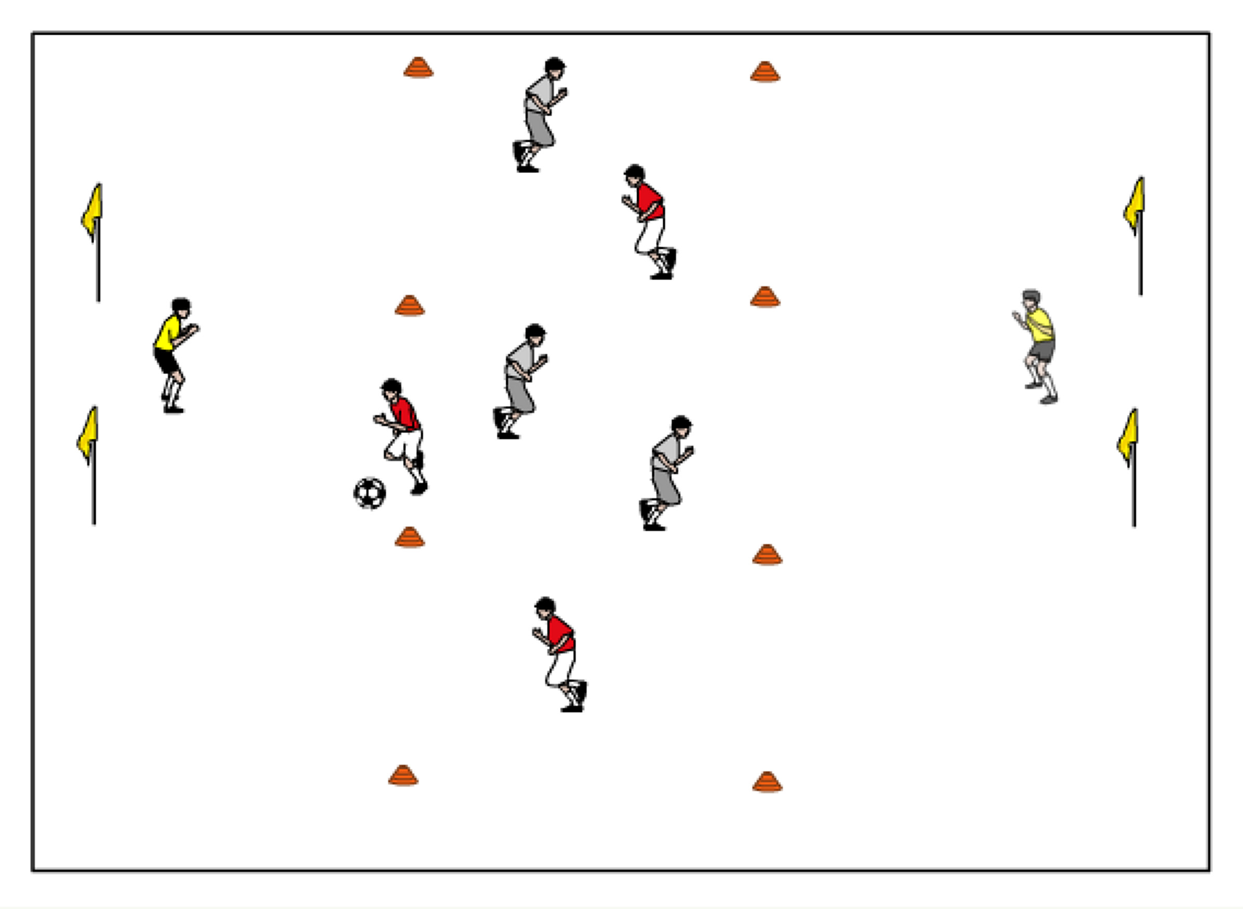
Breakaway Game ---Play a small-sided (3v3 or 4v4) game with two goals, a goalkeeper in each net. Divide the field into thirds (horizontally across width of the field). All players start in the middle zone, and no player on either team may enter a goal zone until after the ball does. This arrangement encourages through balls and breakaways. If necessary, you can add a restriction that only one or two defenders may enter their defensive zone. Keepers must decide whether they should come out immediately when a ball comes through and intercept it, come out and challenge the ball carrier, or stay on the line.
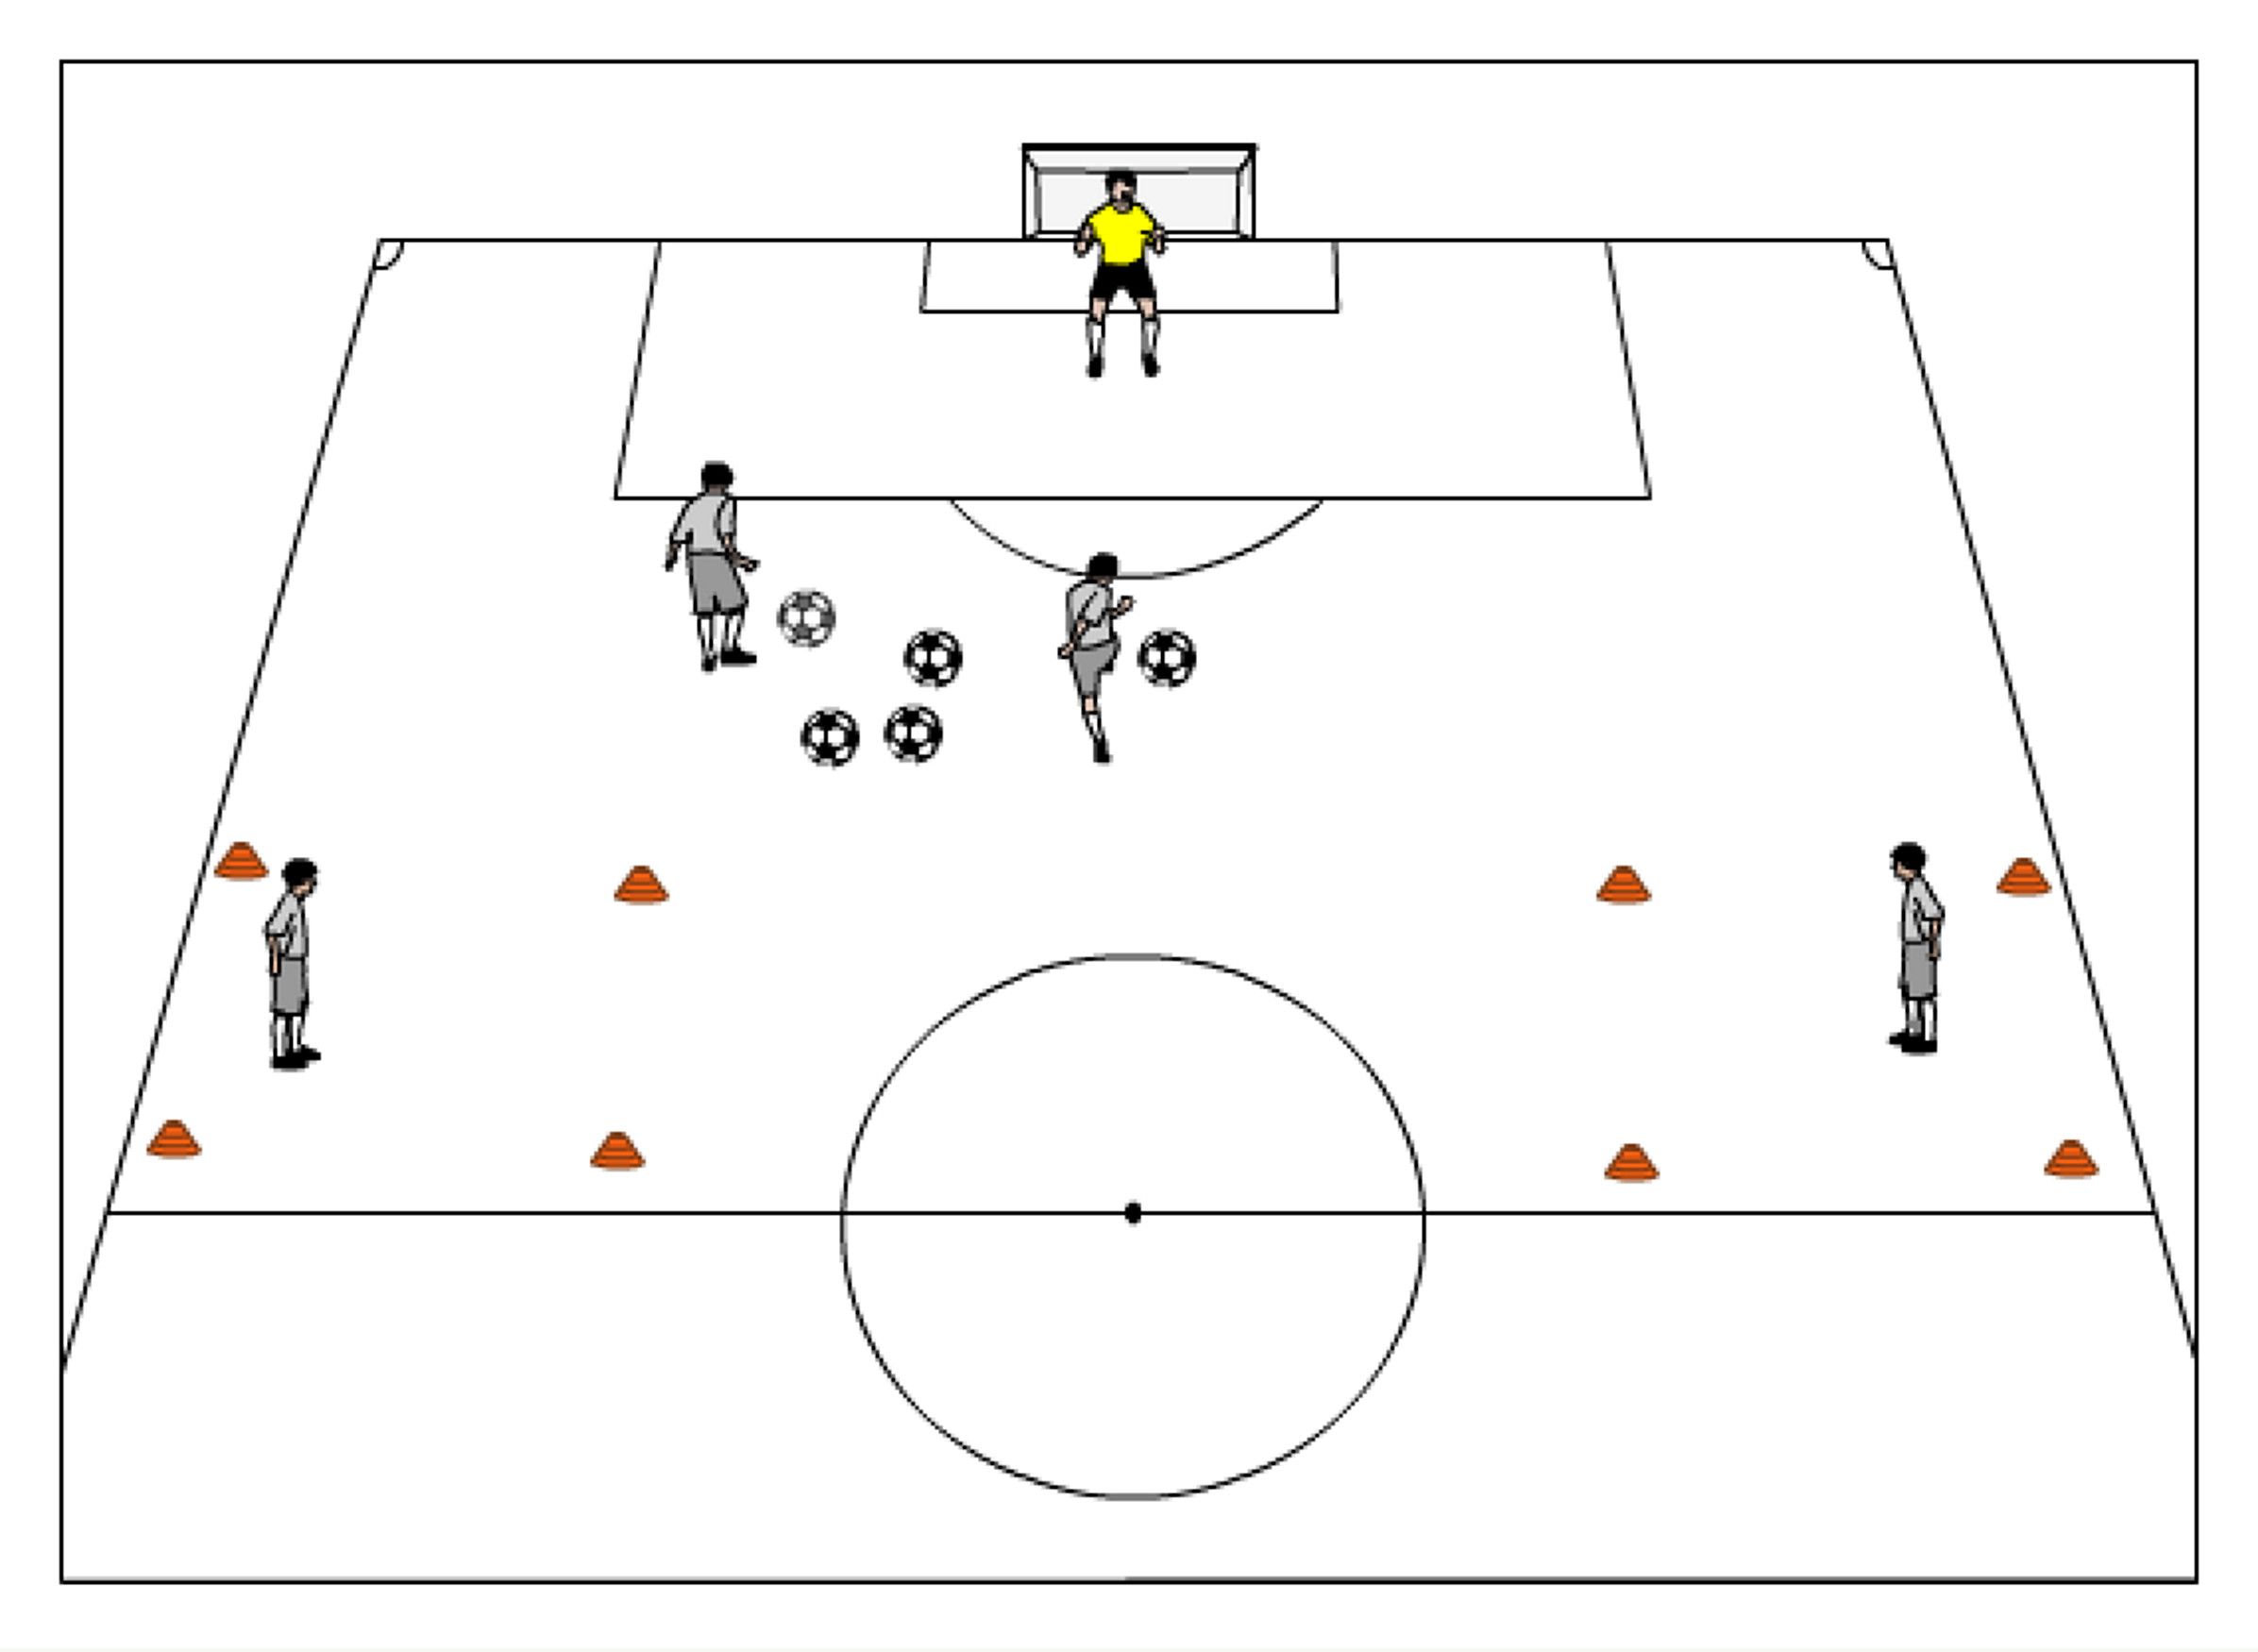
Save and Pass back— GK in net, server is centrally about 25 yards out with all of the balls. A shooter is centrally about 25 yards out as well. Targets at half field (or closer) near the touch line in a 10 yard box. Shooter takes a touch and a shot. After the keeper makes a save, the server passes a ball back to the working GK who takes two touches and connects to one of the grids. Version 2: One touch the ball from the server and connect to targets. Version 3: Have a defender put pressure on working GK, starting their run from the 18 yard line so the GK has to make the right decision to play to the left or right, one touch or two touch. The goalkeepers should take about 8-12 repetitions per round. (two touch, one touch, with defender)

Color Shots – There are different colored cones or jerseys on a central arc about 16-20 yards outside of a goal, each with a server and several balls. One GK starts in net and as the coach calls out a color, the GK must adjust their positioning and be ready for the shot, based on what color the coach calls. Rotate after 5 shots. Each goalkeeper should rotate through at least 4 rounds of saves.

2v2 to goal — 2v2 to goal on a 35-40 yards long by 50 yards wide field. Field players should be divided into two teams (each team at a goal standing in a line at each post). First player in each line comes out to make it a 2v2 game. If a team scores, the two players stay on the field, turn and receive a new ball from their team standing in lines on the post, and attempt to score another goal. If scored on, rotate out. If ball goes out of bounds, both teams rotate off.

1v1 Grid Challenge —An attacking line with field players sets up centrally at one end of the grid (15widex20long) and the GK line at the opposite end. The GK rolls ball to the attacker who must dribble over the opposite endline (the goal the GK is protecting) with possession for a point. Keep track of goals scored for a competition. Maximum 4 players in each the attacking line and GK line. GK should be looking to cut down the angle and force the attacker to one side. (Maximum length of activity: 20 minutes)

